Appendix 5

Time Schedules
Contract on subsidy for carbon capture, transport, and storage

Instructions for Tenderers

This Appendix constitutes General Requirements in its entirety, cf. Tender specifications, paragraph 6.3.

The Tenderer shall complete this Appendix and submit the Appendix as part of the Tenderer’s Offer.

The Appendix should be completed according to the content of this Appendix and R-1, Appendix 3, Requirement specification & Appendix 4, Solution description.

The DEA will require that the Tenderer submits documentation for the entry into all sub-contracts required for the performance of the CCS Activities, e.g., with a CO₂ storage supplier, as part of the deliverables in Milestone 1.3 in this Appendix, and therefore not as part of BAFO.

This guidance text will be deleted by the DEA in connection with conclusion of the Contract.

Introduction

Appendix 5 includes:

- The template for the Operator’s Draft Milestone Plan

- The DEA’s predefined Programme Milestones

- The template for the Operator’s Project Milestone Plan

The Milestone Plan

The Milestone Plan’s purpose is to provide the DEA with a clear overview of how the Operator plans to reach the Commercial Operation Date within the given timeline. The Operator’s objective for this Appendix is to provide the DEA with a transparent and structured completion of the Programme Milestone’s Activities and the Project Milestone Plan and its Activities.

Therefore, the Milestone Plan is split in two tables, Table 1: Draft Milestone Plan and Table 2: Template for the Project Milestone Plan. For each Programme Milestone, the Activities and Timing are to be filled out by the Operator. For each Project Milestone, the Project Milestone, the Activities, and the Timing are to be filled out by the Operator. The Operator can add as many Activities for each Milestone, as deemed relevant.

The Operator shall in addition to the completion of the detailed Programme Milestone Plan also provide a graphical version of the Programme Milestone Plan, as exemplified below, clearly stating the Timing of each Programme Milestone in sub-appendix 5.A, ‘Graphical version of the Programme Milestone Plan’.

Example of a graphical version of the Programme Milestone Plan:

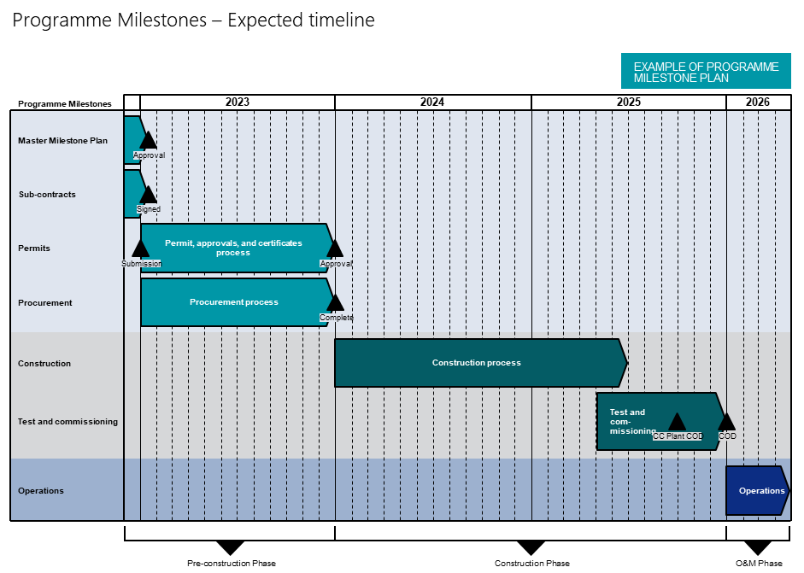

Table 1: Draft Milestone Plan

Programme Milestone Plan
Pre-Construction Phase
Milestone 1.1: Milestone Plan approved |  | Date
The Master Milestone Plan shall be delivered for approval, at the latest 30 days after Contract Signing, to the DEA. The documentation shall be delivered to the DEA’s Contract Owner’s e-mail, cf. Appendix 8, Governance, in a pdf format no later than on the specified date of the Programme Milestone’s completion.

Activities 1.1 |  | Date
1.1.0
1.1.1
1.1.2
1.1.3

Milestone 1.2: All permits, approvals, and certificates are submitted |  | Date
The Operator shall provide to the DEA documentation of the submission of permits, approvals, and certificates needed to initiate construction and operate all the elements of the Value Chain. The documentation shall be delivered collectively in a pdf format to the DEA’s Contract Owner’s e-mail, cf. Appendix 8, Governance, no later than on the specified date of the Programme Milestone’s completion. The documentation should include the name of the permits, approvals, certificates, the date of submission, issuer of the permit, approval, or certificate. If more than one submission date is anticipated by the Operator, an Activity for each submission shall be created by the Operator.

Activities 1.2 |  | Date
1.2.0
1.2.1
1.2.2
1.2.3

Milestone 1.3: All contracts signed |  | Date
The Operator shall provide to the DEA documentation of the entry into all sub-contracts required for the performance of the CCS Activities. The documentation should provide an overview of the sub-contracts, stating the name and registration number of the Sub-Supplier, purpose and scope of the contracts, and the duration of the Contracts. Furthermore, the documentation should also include a copy of each individual Contract entered between the Operator and the Sub-Suppliers. The documentation shall be delivered to the DEA’s Contract Owner’s e-mail, cf. Appendix 8, Governance, in a pdf format no later than on the specified date of the Programme Milestone’s completion.

Activities 1.3 |  | Date
1.3.0
1.3.1
1.3.2
1.3.3

Milestone 1.4: |  | Date
“To be completed by the Operator if deemed relevant”

Activities 1.4 |  | Date
1.4.0
1.4.1
1.4.2
1.4.3

Construction Phase
Milestone 2.1: All permits, approvals, and certificates approved for construction start |  | Date
The Operator shall provide documentation of all approved permits, approvals, and certificates to start construction to the DEA. The documentation should be delivered in a pdf format including an overview of the permits, approvals, and certificates, listing the names of them, the grant date of approval and the issuers of the permits, approvals, or certificates. Furthermore, a copy of each permission, approval, or certificate granted shall be delivered to the DEA’s Contract Owner’s e-mail, cf. Appendix 8, Governance, in a pdf format no later than on the specified date of the Programme Milestone’s completion.

Activities 2.1 |  | Date
2.1.0
2.1.1
2.1.2
2.1.3

Milestone 2.2: All constructions complete |  | Date
The Operator shall deliver to the DEA documentation showing that all construction work required in the Value Chain for performance of the CCS Activities are complete and ready for test and commissioning. The documentation shall be structured in a manner, which enables the DEA to easily separate the documentation for each of the units in the Value Chain. The documentation shall be delivered to the DEA’s Contract Owner’s e-mail, cf. Appendix 8, Governance, in a pdf format no later than on the specified date of the Programme Milestone’s completion.

Activities 2.2 |  | Date
2.2.0
2.2.1
2.2.2
2.2.3

Milestone 2.3: Carbon capture plant operation date |  | Date
The Operator’s carbon capture plant(s) are fully operational, cf. R-15, Appendix 3, Requirements Specification. |  | 01.12.2025
Activities 2.3 |  | Date
2.3.0
2.3.1
2.3.2
2.3.3

Milestone 2.4: Documentation of the Carbon capture plant operation date |  | Date
The Operator shall deliver to the DEA documentation showing that the carbon capture plant(s) are fully operational, cf. Programme Milestone 2.3. The documentation shall be delivered to the DEA’s Contract Owner e-mail, cf. Appendix 8, Governance, in a pdf format no later than on the specified date of the Programme Milestone’s completion. |  | 31.12.2025
Activities 2.4 |  | Date
2.4.0
2.4.1
2.4.2
2.4.3

Milestone 2.5: Test and commissioning done |  | Date
The Operator shall deliver to the DEA documentation showing that all testing and commissioning required for commencement of all elements of the CCS Activities has been successfully completed. The documentation shall be delivered to the DEA’s Contract Owner’s e-mail, cf. Appendix 8, Governance, in a pdf format no later than on the specified date of the Programme Milestone’s completion.

Activities 2.5 |  | Date
2.5.0
2.5.1
2.5.2
2.5.3

Operation & Maintenance Phase
Milestone 3.1: Commercial Operation Date |  | Date
The Operator shall deliver to the DEA documentation of all prior Programme- and Project Milestones completed. All other prerequisites for the Value Chain’s full operation must also be completed. The documentation should list previous Programme- and Project Milestones completed in a structured manner, making the evidence of the completion of each Programme Milestone and Project Milestone transparent to the DEA. The documentation shall be delivered to the DEA’s Contract Owner’s e-mail, cf. Appendix 8, Governance, in a pdf format no later than on the specified date of the Programme Milestone’s completion.

Activities 3.1 |  | Date
3.1.0
3.1.1
3.1.2
3.1.3

Table 2: Template for Project Milestone Plan

Project Milestone Plan 1
Pre-Construction
Project Milestone 1: |  | Date
“To be completed by the Operator”

Activities 1.1 |  | Date
1.1.0
1.1.1
1.1.2
1.1.3
Project Milestone 2: |  | Date
“To be completed by the Operator”

Activities 1.2 |  | Date
1.2.0
1.2.1
1.2.2
1.2.3
Project Milestone 3: |  | Date
“To be completed by the Operator”

Activities 1.3 |  | Date
1.3.0
1.3.1
1.3.2
1.3.3
Project Milestone 4: |  | Date
“To be completed by the Operator”

Activities 1.4 |  | Date
1.4.0
1.4.1
1.4.2
1.4.3
Project Milestone 5: |  | Date
“To be completed by the Operator”

Activities 1.5 |  | Date
1.5.0
1.5.1
1.5.2
1.5.3

Project Milestone 6: |  | Date
“To be completed by the Operator”

Activities 1.6 |  | Date
1.6.0
1.6.1
1.6.2
1.6.3

Project Milestone 7: |  | Date
“To be completed by the Operator”

Activities 1.7 |  | Date
1.7.0
1.7.1
1.7.2
1.7.3

Project Milestone Plan 2
Construction
Project Milestone 1: |  | Date
“To be completed by the Operator”

Activities 2.1 |  | Date
2.1.0
2.1.1
2.1.2
2.1.3
Project Milestone 2: |  | Date
“To be completed by the Operator”

Activities 2.2 |  | Date
2.2.0
2.2.1
2.2.2
2.2.3
Project Milestone 3: |  | Date
“To be completed by the Operator”

Activities 2.3 |  | Date
2.3.0
2.3.1
2.3.2
2.3.3
Project Milestone 4: |  | Date
“To be completed by the Operator”

Activities 2.4 |  | Date
2.4.0
2.4.1
2.4.2
2.4.3
Project Milestone 5: |  | Date
“To be completed by the Operator”

Activities 2.5 |  | Date
2.5.0
2.5.1
2.5.2
2.5.3

Project Milestone Plan 3
Operation & Maintenance
Project Milestone 1: |  | Date
“To be completed by the Operator”

Activities 3.1 |  | Date
3.1.0
3.1.1
3.2.2
3.3.3
Project Milestone 2: |  | Date
“To be completed by the Operator”

Activities 3.2 |  | Date
3.2.0
3.2.1
3.2.2
3.2.3
Project Milestone 3: |  | Date
“To be completed by the Operator”

Activities 3.3 |  | Date
3.3.0
3.3.1
3.3.2
3.3.3
Project Milestone 4: |  | Date
“To be completed by the Operator”

Activities 3.4 |  | Date
3.4.0
3.4.1
3.4.2
3.4.3
Project Milestone 5: |  | Date
“To be completed by the Operator”

Activities 3.5 |  | Date
3.5.0
3.5.1
3.5.2
3.5.3

