EUROPEAN COMMISSION
DIRECTORATE-GENERAL
TAXATION AND CUSTOMS UNION
Digital Delivery of Customs and Taxation Policies
Taxation Systems & Digital Governance

Application User Manual
CBAM Declarant Portal
Date: | 02/10/2023
Status: | Submitted for acceptance (SfA)
Version: | 1.10 EN
Author: | SOFT-DEV
Approved by: | DG TAXUD
Reference number: | DLV-379-7.3-202-1-28
Public: | DG TAXUD external
Confidentiality: | Publicly available (PA)

Document control information

Property | Value
Title | Application User Manual
Subtitle | CBAM Declarant Portal
Author | SOFT-DEV
Project owner | Head of Unit of DG TAXUD Unit C2 Indirect taxes other than VAT
Solution provider | DG TAXUD Unit B2 Architecture & Digital Operations
DG TAXUD Project Manager | Georgios Kavroulakis
Version | 1.10 EN
Confidentiality | Publicly available (PA)
Date | 02/10/2023

Contract information

Property | Value
Framework Contract | TAXUD/2021/CC/162
Specific Contract | SC13

Document history
The document author is authorised to make the following types of changes to the document without requiring that the document be re-approved:
- Editorial, formatting, and spelling;
- Clarification.
To request a change to this document, contact the document author or project owner.
Changes to this document are summarised in the table in reverse chronological order (latest version first).
Version | Date | Description | Action | Section
1.10 | 02/10/23 | Implementing IVE’s comments.  Document re-submitted for acceptance (re-SfA) | R | As required
1.00 | 28/09/2023 | Implementing reviewers’ comments.  Document submitted for acceptance (SfA) | I, R | As required
0.10 | 28/08/2023 | Document submitted for review (SfR) | I | All
0.01 | 05/08/2023 | Document submitted for information (SfI)
Action: I=Insert R=Replace

Configuration management: document location
No previously accepted version of this document exists.

Table of contents
1 Introduction 8
1.1 Document purpose 8
1.2 Target audience 8
1.3 Scope 8
1.4 Structure 8
1.5 Reference documents 8
1.6 Applicable documents 9
1.7 Abbreviations & acronyms 9
1.8 CBAM Quarterly report data elements 10
2 General Information 18
2.1 System Overview 18
2.2 Authorized Use Permission 18
2.3 User Support 18
3 Getting Started 19
3.1 Roles and Responsibilities 19
3.2 Access the CBAM Declarant Portal 19
3.3 Exit the CBAM Declarant Portal 20
3.4 Reporting Declarant Home Page 20
3.5 Main Navigation Bar 21
3.6 Generic User Interface Behaviour 22
3.7 Basic System Functions 23
3.7.1 Change UI Language 23
3.7.2 Change Contact Information 23
3.8 Report States Information 23
3.8.1 States description 23
3.8.2 States transition diagram 25
4 Using the System as CBAM Reporting Declarant 26
4.1 Operators Registry 26
4.1.1 Create an operator 26
4.1.2 Delete an operator 28
4.1.3 Edit an operator 28
4.2 Installations Registry 29
4.2.1 Create an installation 29
4.2.2 Delete an installation 32
4.2.3 Edit an installation 32
4.3 My quarterly reports 33
4.4 Report Structure & Navigation 33
4.4.1 Header level of the CBAM Report 35
4.4.2 CBAM goods Level of the CBAM Report 39
4.4.3 Emissions level of CBAM report 45
4.5 Report actions 53
4.5.1 Create a report 53
4.5.2 Upload a report 54
4.5.3 Save a draft report 55
4.5.4 Delete a draft report 55
4.5.5 Edit a report 56
4.5.6 Validate a report 57
4.5.7 Submit a report 58
4.5.8 View a report 58
4.5.9 Amend a report 58
4.5.10 Invalidate a report 60
4.5.11 Request to submit a report with a delay 60
4.5.12 Download PDF 61
4.5.13 History 61
4.6 My importers 62
4.7 My Profile Information 63
4.8 Preferences 64
5 Appendix 66
6 Annex 67
6.1 CBAM Report (XSD) 67
6.2 Sample ZIP file 67

List of tables
Table 1: Reference documents 8
Table 2: Applicable documents 9
Table 3: Abbreviations and acronyms 10
Table 4: Definitions 17
Table 5 CBAM List of states 24

List of figures
Figure 1 UUM&DS authentication page 19
Figure 2 CBAM Declarant Portal - Main Dashboard 20
Figure 3 Sign-out 20
Figure 4 CBAM Portal – Reporting Declarant Home Page 21
Figure 5 CBAM Reporting Declarant Home Page with expanded navigation bar 22
Figure 6 Mandatory fields indication 22
Figure 7 Maximum number of characters indication 22
Figure 8 Validation errors 23
Figure 9 State Transition Diagram 25
Figure 10 Operator - Create 26
Figure 11 Operator Details Screen 27
Figure 12 Create an Operator 27
Figure 13 Operators Registry 27
Figure 14 Operator Registry - Delete action. 28
Figure 15 Operator Delete - Confirmation message. 28
Figure 16 Operators' registry 28
Figure 17 Operation - Save & Cancel 29
Figure 18 Installations Registry 29
Figure 19 Installation - Details 30
Figure 20 Installation-Search in third country installation operators registry 30
Figure 21 Search in operators registry 31
Figure 22 Installation - Linked Operator Details 31
Figure 23 Installation - Create Button 32
Figure 24 Installation Registry -Delete action 32
Figure 25 Installation Delete - Confirmation message. 32
Figure 26 Installation Registry - Edit Action 32
Figure 27 Installation -Cancel and Save buttons. 33
Figure 28 My Quarterly Reports 33
Figure 29 CBAM Report Data Model 34
Figure 30 Header - Validation 35
Figure 31 Header - Reporting Declarant tab 36
Figure 32 Declarant acts as importer Checkbox 36
Figure 33 Header- Importer tab 37
Figure 34 Declarant acts as representative checkbox 37
Figure 35 Header - Representative Tab 38
Figure 36 Header -Signatures tab 38
Figure 37 Add good 39
Figure 38 Delete good 39
Figure 39 Delete good -Confirmation 39
Figure 40 Edit good 40
Figure 41 Non-validated good 40
Figure 42 Validate Good 41
Figure 43 Validate good – Navigation tree indication 41
Figure 44 Good Level - Importer tab 42
Figure 45 Good Level - Add Importer 42
Figure 46 Good’s level - Representative tab 42
Figure 47 Good’s level - Add Representative 43
Figure 48 Goods imported tab 43
Figure 49 HS sub-heading code selection 44
Figure 50 Imported quantity per customs procedure 44
Figure 51 Goods measure per procedure 45
Figure 52 Goods - Supplementary tab 45
Figure 53 Goods - Add supporting documents. 45
Figure 54 Add an emission. 46
Figure 55 Delete emission. 46
Figure 56 Edit good 47
Figure 57 Installation - Country of production 47
Figure 58 Emissions - Operator (The company name of the installation) 48
Figure 59 Emissions - Operator (Information filled in from Operator Registry) 48
Figure 60 Emissions - Installation fields 49
Figure 61 Emissions-Installation information filled in from Installations Registry 49
Figure 62 Emissions tab - Applicable to Electricity good 50
Figure 63 Emissions tab- Applicable for all goods except electricity 50
Figure 64 Production Method (sample) 50
Figure 65 Direct emissions qualifying parameters 51
Figure 66 Add new qualifying parameters 51
Figure 67 Indirect Emissions qualifying parameters 51
Figure 68 Carbon price due tab 52
Figure 69 Carbon price due -Details 52
Figure 70 Supplementary tab 53
Figure 71 Emissions - Supplementary - Supporting Documents 53
Figure 72 My Quarterly Reports - Create Report 54
Figure 73 My Quarterly Reports - Upload a report. 54
Figure 74 Upload ZIP 54
Figure 75 Save a draft report 55
Figure 76 Delete a draft report. 56
Figure 77 Delete draft report - Confirmation message 56
Figure 78 Edit a report. 57
Figure 79 Edit a report 57
Figure 80 Validate report 57
Figure 81 Submit report. 58
Figure 82 View report 58
Figure 83 Amend a report. 59
Figure 84 Invalidate a report. 60
Figure 85 Invalidate report confirmation message. 60
Figure 86 Request delay 60
Figure 87 Download PDF 61
Figure 88 History 61
Figure 89 History 62
Figure 90 My Importers -Starting point. 62
Figure 91 List of my importers 62
Figure 92 Importer Profile 63
Figure 93 Importer - Goods Imported 63
Figure 94 My profile information 64
Figure 95 Preferences menu 64
Figure 96 Preferences 65
Figure 97 Edit Preferences 65

Introduction

Document purpose
The purpose of this document is to provide directions to reporting declarants and CBAM declarants (referred to in this document CBAM declarants) on how to utilise the CBAM Trader Portal (referred to in this document CBAM Declarant Portal).

Target audience
The target audience for this document includes:
- Importers of CBAM goods into the EU or their authorised representatives (reporting declarants or CBAM declarants)
- Directorate-General Taxation and Customs Union (DG TAXUD) Project team;
- Directorate General for Informatics (DIGIT);
- Directorate-General for Climate Action (DG CLIMA);
- EU Member states and their National Competent Authorities;
- SOFT-DEV Project team;
- Quality Assurance Contractor;
- Operational teams.

Scope
The scope of this document is to provide directions to CBAM Reporting Declarants on the effective utilisation of the CBAM Declarant Portal. The features described comply with CBAM Release 1.1

Structure
This document is organised as follows:
- Chapter 1 – Introduction: describes the scope and the objectives of the document.
- Chapter 2 – General Information: provides the practical and theoretical details for the topic treated in the document;
- Chapter 3 –Getting Started details how to access the portal and introduces the basis system functions.
- Chapter 4 - Using the System as CBAM Reporting Declarant describes the CBAM Declarant Portal functionalities.

Reference documents
The table below lists the documents that are referred to in the current document.
Ref. | Title | Originator | Version | Date
R01 | User Registration procedure for CBAM Reporting Declarants | TBA | TBA | TBA
Table 1: Reference documents

Applicable documents
The table below lists the documents to which the current document must be compliant (e.g. FWC, SC, RfA).
Ref. | Title | Originator | Version | Date
A01 | SOFT-DEV Framework Quality Plan | SDEV-FQP | 1.00 | 10/01/2023
A02 | SOFT-DEV Framework Contract | TAXUD/2021/CC/162 | N/A | 24/06/2021
A03 | Specific Contract 13 | TAXUD/2023/DE/134 | N/A | 05/04/2023
A04 | RfA-379 - CARBON BORDER ADJUSTMENT MECHANISM (CBAM) – Transitional Period IT system Release 1.10 | Ares(2023)4500958 | 1.20 | 29/06/2023
Table 2: Applicable documents

Abbreviations & acronyms
For a better understanding of the present document, the following table provides a list of the principal abbreviations and acronyms used.
See also the ‘list of acronyms’ on TEMPO.
Abbreviation/Acronym | Definition
CBAM | Carbon Border Adjustment Mechanism
CN | Combined Nomenclature
CO2 | Carbon Dioxide
COM | European Commission
CRS | Customs Customer Reference Services
CS/RD2 | Central Services Reference Data
DG CLIMA | Directorate-General for Climate Action
DG TAXUD | Directorate General for Taxation and Customs Union
DIGIT | Directorate General for Informatics
DOC | Microsoft Word document
DOCX | Microsoft Word Open XML format document
EORI | Economic Operators Registration and Identification
ETS | Emissions Trading System
EU | European Union
GNSS | Global Navigation Satellite System
GPS | Global Positioning System
HS | Harmonized System Codes
ID | Identification number
JPEG | Joint Photographic Experts Group
MIME | Multipurpose Internet Mail Extensions
MS | Member State
MWH | Megawatt Hour
N/A | Not available
NCA | National Competent Authority
NIS | National Import System
PDF | Portable Document Format
PSM | Public-Subscribe Mechanism
SfA | Submitted for Acceptance
SfI | Submitted for Information
SfR | Submitted for Review
SPEED2ng | SPEED2 Gateway is used for exchanging messages with partner countries (for example MRA exchanges, NCTS TIR messages and in the future SSTL messages). The messages are exchanged via dedicated VPN links and the exchange protocols vary (Web Services, MQ Asynchronous Transport Protocol, AS2, AS3 and AS4 protocols).
UCC | Union Customs Code
UI | User Interface
URI | Universal Resource Identifier
URL | Uniform Resource Locator
UUM&DS | Uniform User Management and Digital Signatures
XLS | Microsoft Excel spreadsheet file
XLSX | Microsoft Excel Open XML spreadsheet file
XML | eXtensible Markup Language
XSD | XML Schema Definition
ZIP | Compressed file
Table 3: Abbreviations and acronyms

CBAM Quarterly report data elements
For a better understanding of the present document, the following table provides a list of the principal terms used.
See also the ‘glossary’ on TEMPO.
Field Name | Description
Report issue date | The date that the CBAM report is submitted.
Draft report ID | The unique ID that the Reporting Declarant inserts when the report is created (and saved) to identify their report.
Report ID | This unique ID is allocated by the system once the report is submitted.
Reporting Period | The Quarter of the year. This is a CBAM Local List that contains the Quarters of a year (Quarter1, Quarter2, Quarter3, Quarter 4).
Year | The year for which the report is submitted.
Total goods imported | The total goods that are declared in the CBAM report.
Total emissions | The total of the emissions for all the goods declared in the CBAM report.
Reporting Declarant | Information about the Reporting Declarant per Implementing regulation (17/8/23).
Identification number | The ID of the Reporting Declarant. This is their EORI number.
Name | The full name (person or company) of the Reporting Declarant.
Role | The role that the Reporting Declarant has. If they are the importer or a representative.
Importer | The entity that contains information about the Importer that is represented by the Reporting Declarant. The Importer can either be declared at Header level, if the same importer is common for all goods Imported, or in the goods Imported level.
Remarks | An entity that exists in all levels of the report in order the Reporting Declarant to insert additional information.
Additional Information | In this element, the Reporting Declarant can write any additional information that applies in the location where it is positioned.
CBAM goods imported | Entity that contains the information for the CBAM good. There may be up to 99999 CBAM goods in a CBAM report.
Goods item number | This element specifies the item number of every CBAM good imported of the CBAM Report. It is a sequential number.
Commodity code | An entity that contains the HS Code and the CN Code of the CBAM good.
Harmonized System sub-heading code | The classification code of the CBAM good. It is a 6-digit code.
Combined nomenclature code | The CN Code of the CBAM good. The code consists of the HS Code plus 2 additional digits.
Commodity details | An entity that contains the description element of the CBAM good.
Description of good | An element that can be used in order to describe the CBAM good.
Country of origin | An entity to declare the Country of Origin of the CBAM good.
Procedure | An entity that contains the Customs Procedures.
Requested Procedure | The Customs Requested Procedure.
Previous procedure | The Customs Previous Procedure.
Area of import | An entity that contains the area of import element.
Area of import | The area where the CBAM good was imported. Two possible values: EU by means of Customs import declaration and EU by other means.
Good measure | The entity that contains the quantity of the CBAM good.
Net mass | The Net mass is to be used for the CBAM goods that are measured in kgs (or in tonnes).
Supplementary units | The Supplementary units is to be used for the CBAM goods that have a special measurement unit such as hydrogen.
Type of measurement unit | The type of measurement unit of the quantity of the CBAM good.
Special references for goods | An entity to use in case there are special references related to the CBAM good.
Goods imported total emissions | The entity that contains the information for the overall emissions of the CBAM goods.
Goods total emissions | The total emissions of direct and indirect emissions.  The value of this field must be equal to the sum of good direct emissions + good indirect emissions.
Goods direct emissions | This element is used to hold the total emissions of direct emissions.  The value of this field must be equal to the sum of all the installation direct emissions.
Goods indirect emissions | This element is used to hold the total emissions of indirect emissions.  The value of this field must be equal to the sum of all the installation indirect emissions.
Type of measurement unit for emissions | This element is to indicate that the emissions are measured in tonnes.
Supporting documents (for good) | This entity exists in the CBAM good’s imported level. It used to provide any supporting documents.
Supporting Documents (for emissions definition) | This entity exists in the CBAM good’s emissions level. It used to provide any supporting documents.
Type | The type of supporting document (it is in the Supporting Documents (for goods).
Type of emissions document | This element is used to define the type of emissions document that is declared. It is in the Supporting Documents (for emissions definition).
Country of document issuance | The country where the supporting document was issued.
Reference number | The reference number of the supporting document.
Document line item number | The document line item number is the number of the goods imported entry in which the supporting documents corresponding to.
Issuing authority name | The authority that issued the supporting document.
Validity start date | The start date of validity of the supporting document.
Validity end date | The end date of validity of the supporting document.
Description | A text element to describe the supporting document.
Attachments | An entity that exists in good’s imported and good’s emissions level. It is used to attach a file or provide a URL.
Filename | The file name of the attachment.
URI | The URI link of an attachment.
MIME | The MIME of the attachment.
Included binary object | The actual binary object.
CBAM goods emissions | The entity for the CBAM good emissions. For each CBAM good, there can be up to 999 entries for each CBAM good.
Emissions sequence number | This element specifies the number of every CBAM good’s emission. It is a sequential number.
The company name of the installation | An entity to define the information related to the company name of the installation.
Operator ID | The unique identification number of the operator.
Operator Name | The Name of the operator.
Address (of the company name of the Installation) | This entity is to define the Address details of the Installation operator.
Sub-division | The sub-division where the Operator is located.
City | The city where the Operator is located.
Street | The street name where the Operator is located.
Street additional line | Additional information for the street name where the Operator is located.
Number | The number of the street where the Operator is located.
Postcode | The postcode of the location of the Operator.
P.O. Box | The P.O. box of the address.
Contact Details | This entity is to define the Contact Details of the Installation Operator.
Name | The name of the person that is assigned in the contact details of the operator.
Phone number | The phone number of the person that is assigned in the contact details of the operator.
e-mail | The email of the person that is assigned in the contact details of the operator.
Installation | This entity is to define the Installation (Factory) information where the CBAM good is produced.
Installation ID | The unique ID of the Installation.
Installation name | The name of the Installation.
Economic activity | The definition of the economic activity of the installation.
Address (of the Installation) | The address of the Installation.
Country of establishment | The country where the installation that produced the good or the Reporting Declarant is established.
Plot or parcel number | The plot or parcel number.
UNLOCODE | The UNLOCODE as defined in UCC Annex B.
Latitude | The latitude of the coordinates.
Longitude | The longitude of the coordinates.
Type of coordinates | The type of coordinates (GPS/GNSS).
Goods measure (Produced) | The entity that contains the quantity of the CBAM good that is produced in the specific installation.
Installation emissions | The entity that contains the emissions that were produced in the good’s emissions.
Installation total emissions | The total quantity of emissions produced for the particular good's quantity. The value of this field must be equal to the sum of Installation direct emissions + Installation indirect emissions.
Installation direct emissions | The quantity of Installation’s direct emissions produced for the particular good's quantity. The value of this field must be equal with the result of the following formula: good’s measure x Specific (direct) embedded emissions.
Installation indirect emissions | The quantity of indirect emissions produced for the specific particular goods’ quantity. The value of this field must be equal with the result of the following formula: good’s measure x Specific (indirect) embedded emissions.
Direct Embedded Emissions | The entity that contains the information related to the direct embedded emissions.
Type of determination | The type of determination of the direct embedded emissions. The possible values are: Actual data, Default value.
Type of applicable reporting methodology | The type of applicable reporting methodology used to calculate the emissions of the CBAM good while being produced.
Applicable reporting methodology | The actual applicable reporting methodology used.
Specific (direct) embedded emissions | The element to declare the emissions per measurement unit of the product produced.
Indirect Embedded Emissions | The entity that contains the information related to the indirect embedded emissions (not applicable to electricity good’s entries).
Specific (indirect) embedded emissions | The element to declare the emissions per measurement unit of the product produced.
Electricity consumed | The electricity consumed (MWH per measurement unit of product).
Emission factor | The value of this element is expressed in tonnes of CO2 per MWH.
Source of emission factor | This element is used to declare literature or published information by the statistics office.
Other source indication | This element is used to declare a different source.
Source of electricity | This element is used to declare the source of electricity. Possible values: “Auto-produced”, “(bilateral) power purchase agreement”, “received from the grid".
Production method & Qualifying parameters | This entity contains the information related to the Production method and the emissions qualifying parameters.
Method ID | The unique ID of the production method.
Method name | The production method name.
Direct Emissions qualifying parameters | This entity contains the information related to the direct emissions qualifying parameters.
Indirect Emissions qualifying parameters | This entity contains the information related to the indirect emissions qualifying parameters.
Carbon price due | This entity is used to provide information regarding CO2 emissions that were due.
Type of instrument | This element is used to describe the type of instrument used. Possible values are Carbon tax, Carbon price paid in the context of a national ETS, Carbon price paid in the context of a regional ETS.
Description and indication of legal act | This element is used to reference the description of the legal act.
Amount of the carbon price due | The amount of the CO2 emissions due.
Currency | The currency used for the declared amount to be paid.
Exchange rate | The exchange rate of the currency is related to EURO. This is a baseline exchange rate defined by the European commission.
Amount (EURO) | The corresponding amount in EURO.
Goods covered under carbon price due | This entity is used to provide information regarding the goods for which the CO2 emissions were due.
Type of goods covered | The type of goods in scope of the CBAM and imported into the EU during the reporting period.
CN code of goods covered | The CN code of the product covered. This is used only for information purposes.
Quantity of emissions covered | Used in “Carbon Price Due” section. Refers to the quantity of emissions covered by the carbon price already paid.
Quantity covered by free allocations, any  rebate or any other form of compensation | Used in “Carbon Price Due” section. The quantity of emissions covered by any form of compensation.
Supplementary information | This element is used to enter any supplementary information related to the product covered under price paid.
Goods measure (Covered) | This entity is used to provide the quantity of the good for which the emissions are already paid.
Third country | A country or territory outside the customs territory of the Union where CBAM regulation applies.
Continental shelf | The continental shelf as defined in the United Nations Convention on the Law of the Sea.
Exclusive economic zone | The exclusive economic zone as defined in the United Nations Convention on the Law of the Sea and which has been declared as an exclusive economic zone by a Member State pursuant to that convention.
Default value | The Default value is the intensity of emissions. It expresses the quantity of CO2 emissions per measurement unit of product.
EC Authority | EC Authority for CBAM is the Commission.
MS Authority | The Member State Competent Authority takes part in the CBAM ecosystem. When referring to the EC Authority, it is meant both EC Authority and MS Authority.
Signatures | There are two types of signatures in the CBAM Report. The first one is related to the information in the report. The Reporting Declarant must confirm that the information in the CBAM report is accurate and complete. The second is only applicable if the type of applicable rules selected is not CBAM-specific. In this case, the Reporting Declarant must confirm that the used applicable rules are comparable to the CBAM applicable rules.
Report confirmation | This entity is used to hold the confirmation related to the contents of the CBAM Report.
Report global data confirmation | This element holds the confirmation of the Reporting Declarant regarding the information of the CBAM Report.
Use of data confirmation | This element holds the confirmation of the Reporting Declarant regarding his approval to use the data of the CBAM Report for the review process.
Date of signature | This element holds the date when the confirmation was signed.
Place of signature | This element holds the place where the confirmation was signed.
Signature | Full name of the Reporting Declarant.
Position of the person signing | Position of the person signing the CBAM declaration within the Reporting Declarant’s legal entity.
Type of applicable reporting methodology confirmation | This entity is used for the confirmation of the type of applicable reporting methodologies, in case the selected one is not the CBAM-specific.
Other applicable reporting methodology confirmation | This element is used to hold the confirmation of the “other” applicable reporting methodology used.
Representative | This entity is to define the information about the Representative in the CBAM Report. The Representative can either be declared at Header level, if the same representative is common for all goods Imported, or alternatively in the good’s Imported level.
Member State of establishment | The country where the Reporting Declarant or the Representative is established.
Member state or Country of establishment | The country where the Importer is established (either a Member state of the EU or a third country).
Competent Authority | This entity contains information regarding the Competent Authority where the Reporting Declarant is established.
Reference Number | The Name or Reference number of the Competent Authority.
Imported quantity per customs procedure | The Entity that contains information regarding the Customs procedures and the related quantities of the CBAM good.
Inward processing information | This entity contains information regarding the Inward processing procedure.
Member State of inward processing authorisation | The Member State which authorised the inward processing.
Inward processing waiver for Bill of discharge | The Inward processing waiver for the Bill of discharge.
Authorisation | The Authorisation related to the inward processing.
Globalisation time start | Inward processing authorization start date
Globalisation time end | Inward processing authorization end date.
Deadline for submission of Bill of discharge | The deadline for the submission of the Bill of discharge. Typically, it will be one month after the end date of the Globalisation timer.
Good’s measure (per procedure) | This Data Group contains the quantity of the CBAM good per Customs procedure.
Procedure indicator | The procedure indicator. When checked, it refers to Inward Processing procedure
Type of determination for electricity | The type of determination of the direct embedded emissions in case the CBAM good is electricity.
Source of emission factor (for electricity) | The source of emission factor in case the CBAM good is electricity.
Electricity imported | The quantity of electricity imported. This entity is only applicable in the direct embedded emissions when CBAM Good is electricity.
Total embedded emissions of electricity imported | The amount of CO2 tonnes produced for the quantity of the electricity imported. It is only applicable in the direct embedded emissions when CBAM good is electricity.
Source of emissions factor value | Used to declare any extra information regarding the source of the emissions value. It is only applicable in the direct embedded emissions when CBAM good is electricity.
Justification | Used to justify the alternative default value used in the emission factor. It is only applicable in the direct embedded emissions when CBAM good is electricity.
Fulfillment of conditionality | Used to declare any information related to the actual data declared. It is only applicable in the direct embedded Emissions when CBAM good is electricity.
Table 4: Definitions

General Information

System Overview
Carbon Border Adjustment Mechanism (CBAM) Declarant Portal is the interface offered to CBAM Reporting Declarants to submit & manage the quarterly reports in the CBAM Transitional Registry.
CBAM Regulation will start applying, without financial adjustments, as of 1st October 2023 followed by a transitional period until 1st January 2026. During this period importers of goods falling within the scope of the CBAM will only have to report greenhouse gas emissions embedded in their imports and there will be no financial adjustment.
Importers have to report on a quarterly basis the embedded emissions in goods imported during the previous quarter of the calendar year, declaring direct and indirect emissions as well as any carbon price effectively paid abroad. This reporting-only process will apply until the end of 2025, with the last CBAM report, for the fourth quarter of 2025 (1st October - 31st December) to be submitted by 31st January 2026.
Any CBAM goods importer established in an EU Member State is liable to submit the reports in CBAM Declarant Portal. Per Article 2 Definitions in Implementing Regulation (17/8/2023), the CBAM Report can be submitted by one of the following:
(a) the importer who lodges a customs declaration for release for free circulation of goods in its own name and on its own behalf;
(b) the person, holding an authorisation to lodge a customs declaration referred to in Article 182(1) of Regulation (EU) No 952/2013, who declares the importation of goods;
(c) the indirect customs representative, where the customs declaration is lodged by the indirect customs representative appointed in accordance with Article 18 of Regulation (EU) No 952/2013, when the importer is established outside the Union or where the indirect customs representative has agreed to the reporting obligations in accordance with Article 32 of Regulation (EU) 2023/956.
A CBAM Reporting Declarant can submit a report for multiple importers if needed.
The CBAM Declarant Portal is accessible using internet browsers. Authorisation is provided by UUM&DS.

Authorized Use Permission
CBAM Declarant Portal is allowed to be used by CBAM Reporting Declarants who are registered in UUM&DS.

User Support
CBAM Reporting Declarants need to contact their respective National Competent Authority Service Desk both for business & technical issues.

Getting Started

Roles and Responsibilities
Access to CBAM Declarant Portal is only allowed to Importers and Indirect Custom Representatives who have registered in UUM&DS and have obtained the CBAM Reporting Declarant Business profile.
Their respective NCA or National Customs Administration (depending on the user access management solution each NCA will opt for) will be responsible to assign the CBAM Reporting Declarant business profile in UUM&DS where applicable. User registration procedure is defined in [R01] listed in 1.5 Reference documents.

Access the CBAM Declarant Portal
Access to the CBAM Reporting Declarant Portal is established via UUM&DS. UUM&DS is used to authenticate CBAM Reporting Declarants.
  - Step #1: The user accesses the following link:
- https://cbam.ec.europa.eu/declarant
  - Step #2: The user is redirected to the application’s UUM&DS authentication page, where the following information needs to be filled in: Country, Type of Actor, Type of ID, ID.
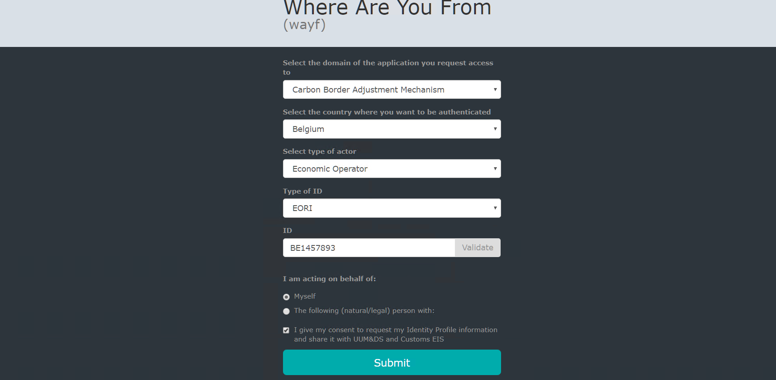
Figure 1 UUM&DS authentication page
  - Step #3: The user is requested to provide the username and password in the next screen based on the authentication system defined in his UUM&DS user profile.
  - Step #4: Upon successful login, the user is redirected to the main dashboard of the CBAM Reporting Declarant Portal.

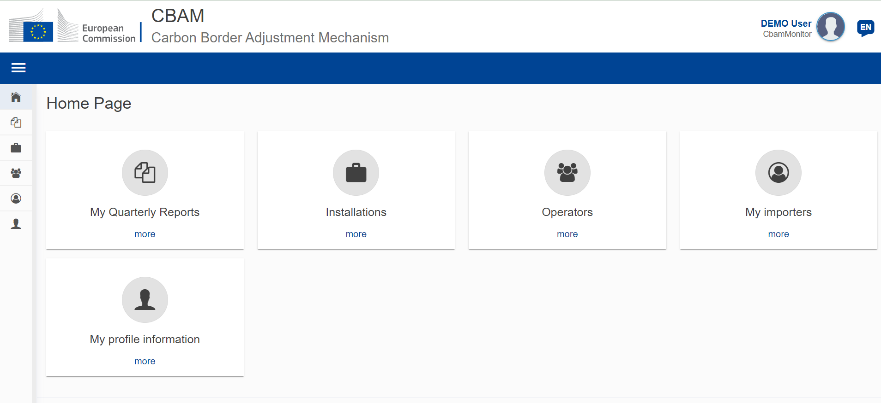
Figure 2 CBAM Declarant Portal - Main Dashboard

Exit the CBAM Declarant Portal
“Sign-out” menu is available in upper right corner of the application. Feature is currently not available in Release 1.1. In the meantime, the browser tab can be closed to exit the application.
Please note that the user is logged out after a certain amount of minutes and UUM&DS will request you to login again.
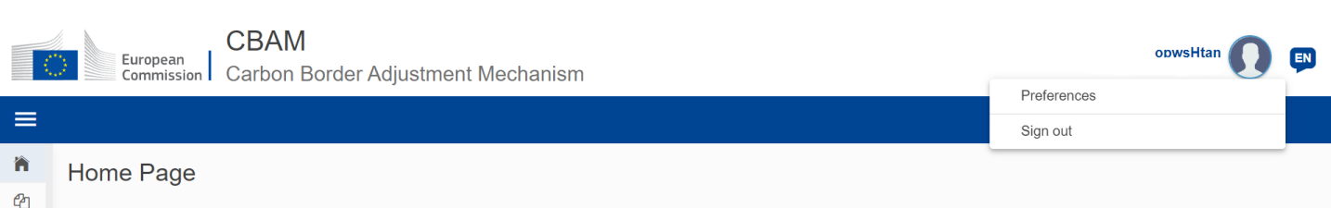
Figure 3 Sign-out

Reporting Declarant Home Page
Once a user is logged in to the CBAM Declarant Portal, the CBAM Portal home page is shown.
The available items are:
- My quarterly reports: When clicked, the Reporting Declarant can see a table organised per quarters of the year. For each quarter, there might be a CBAM report or not. If a CBAM report exists, then the Reporting Declarant can view it. If no CBAM report has been created, and the reporting period is open for submission of CBAM reports, then the Reporting Declarant can create their report or upload it in XML format with attachments packaged in a ZIP file.
- Installations: When clicked, the Reporting Declarant can see the registry of their Installations. They can view the list of Installations inserted, view a specific Installation, edit the entry of an Installation, or delete an Installation. Every Installation has one Operator assigned. It is advised to first create the registry of Operators and subsequently create the registry of Installations.
- Operators: When clicked, the Reporting Declarant can see the Registry of their Operators. They can view their list of Operators inserted, view a specific Operator, edit the entry of an Operator, or delete an Operator.
- My importers: When clicked, the Reporting Declarant who acts as an indirect representative, can see the list of their importers. The Reporting Declarant can select an Importer to view their profile and the associated goods Imported table.
- My profile information: When clicked, the Reporting Declarant can see the information of the logged-in user in the right side and the Reporting Declarant information on the left side.
Figure 4 CBAM Portal – Reporting Declarant Home Page

Main Navigation Bar
The main navigation menu is located on the left side of the screen.
By clicking the icon on the left upper side, the navigation bar on the left is expanded (see Figure 5 CBAM Reporting Declarant Home Page with expanded navigation bar). The options are the same as the ones visible in the Home Page.
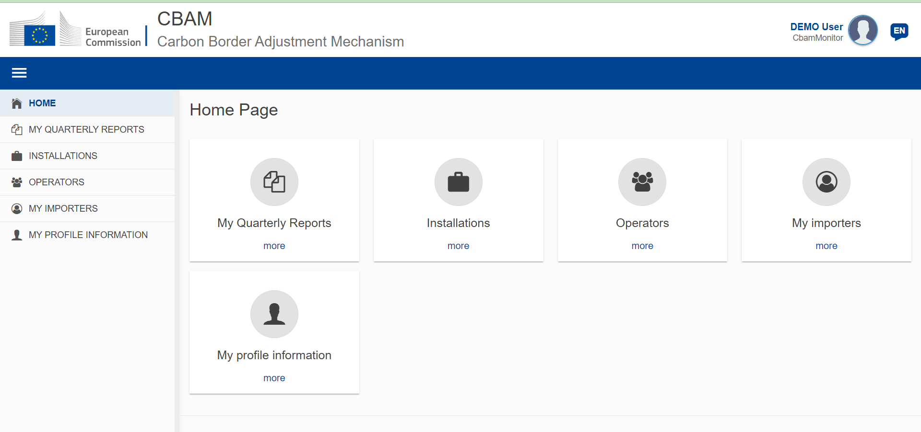
Figure 5 CBAM Reporting Declarant Home Page with expanded navigation bar

Generic User Interface Behaviour
An overview of the generic user interface behaviour is being provided below.
- Report - The fields marked with red asterisk are mandatory.
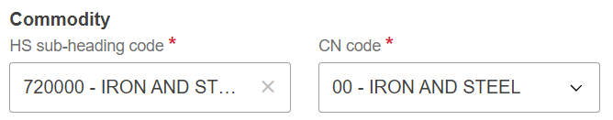
Figure 6 Mandatory fields indication
- Report - The number on the top-right corner of each field is the maximum number of characters that can be entered for the particular field.
Figure 7 Maximum number of characters indication
- Report Validation errors – The validation errors are displayed in each tab. The number displayed within each tab indicates the number of validation errors that need to be addressed.
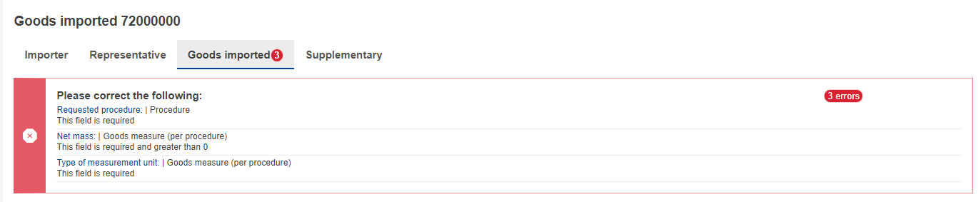
Figure 8 Validation errors

Basic System Functions

Change UI Language
Please follow the instructions in section 4.8 Preferences

Change Contact Information
Please follow the instructions in section 4.7 My Profile Information

Report States Information
This section describes the different states of a CBAM quarterly report and also illustrates the state transitions throughout the CBAM quarterly report lifecycle.

States description
The following table lists all states that a report can have throughout its lifecycle along with their respective descriptions.
States | Description
Draft | Initial state. The report is under preparation by the CBAM Reporting Declarant
Submitted | The report has been submitted
Under amendment | The report is under amendment by the CBAM Reporting Declarant
Invalidated | The report was invalidated by the CBAM Reporting Declarant. A new report can be created for this reporting period
Registered | The report has been officially registered and is available for further actions by EU & NCA Authorities. The report changes to Registered automatically upon expiration of the reporting timer.
Under assessment (COM) | The report is under assessment by European Commission
Assigned to NCA | The report is assigned to the respective NCA
Under review (NCA) | The review process has started by the NCA
Discarded | The report has been Discarded by the NCA. This is a final state.
Under correction | The report is under correction by the CBAM Reporting Declarant (either upon request from NCA or CBAM Reporting Declarant when the state of the review is Under Review (NCA))
Under litigation | The report is under litigation
Finalized | The report evaluation has been completed.  Future potential states are Revoked or Archived
Revoked | Once a report is finalized the state can change to Revoked.
Archived | Once a report is finalized the state can change to Archived.
Table 5 CBAM List of states

States transition diagram
The following State Transition Diagram illustrates the full lifecycle of a CBAM quarterly report, the interaction between the Reporting Declarant and the CBAM System, as well as the interaction between Commission (COM) and National Competent Authorities (NCAs) with the CBAM System in terms of the CBAM quarterly report review.
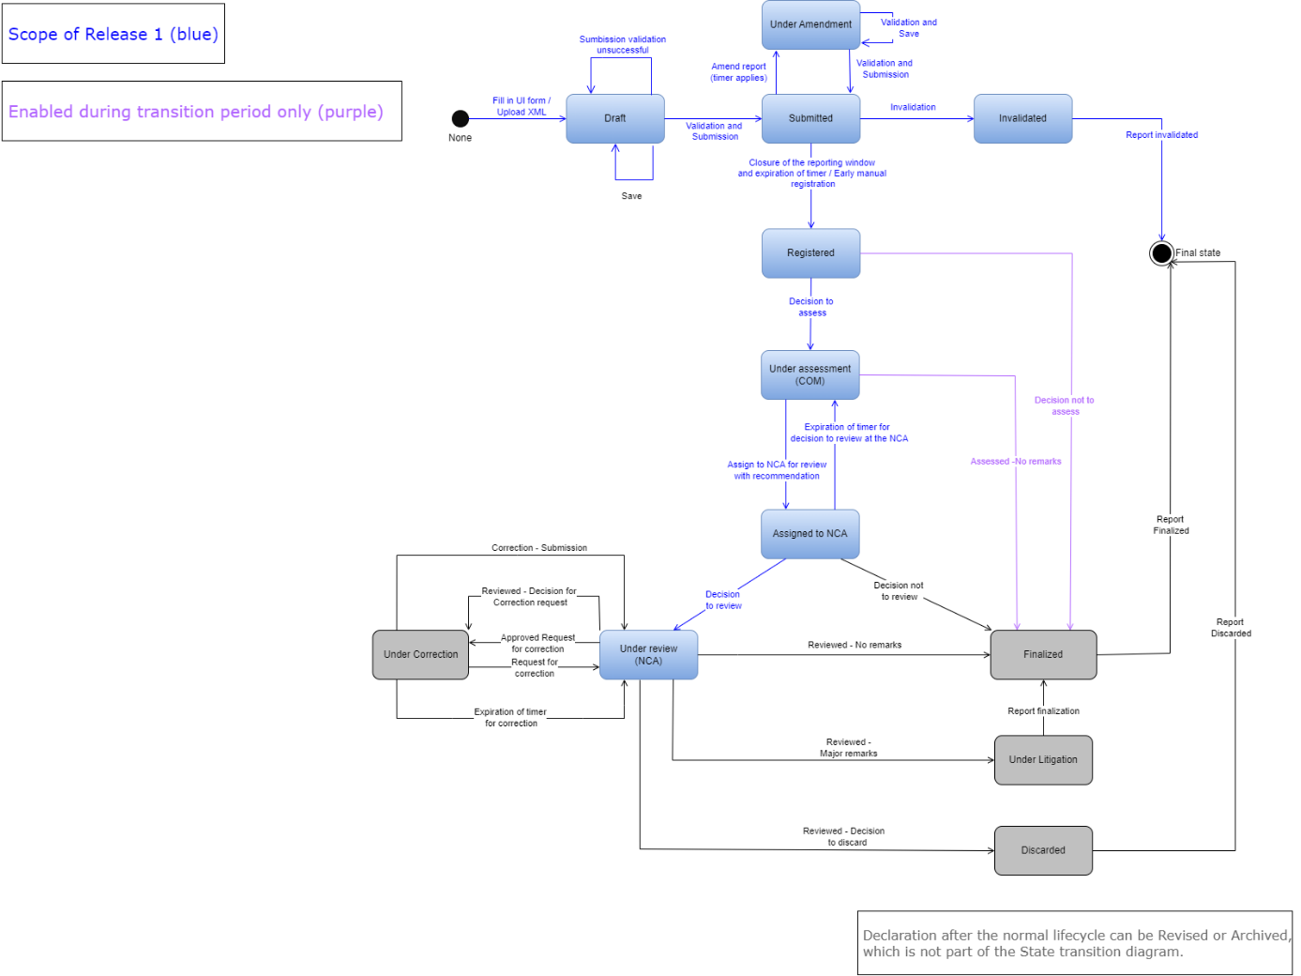
Figure 9 State Transition Diagram

Using the System as CBAM Reporting Declarant
In this section the main actions that a CBAM Reporting Declarant can perform in the CBAM Declarant Portal are being described.

Operators Registry
CBAM System allows to store information for operators of production installations in third countries. It is suggested to store operators in operator’s registry to easily prefill the relevant information when a report is created.

Create an operator
- Open the "Operators Registry" either by clicking on "Operators" icon from the Home Page dashboard or by clicking on "Operators" link in the left side navigation menu.
- Click the “Create an Operator” button on the upper right corner.
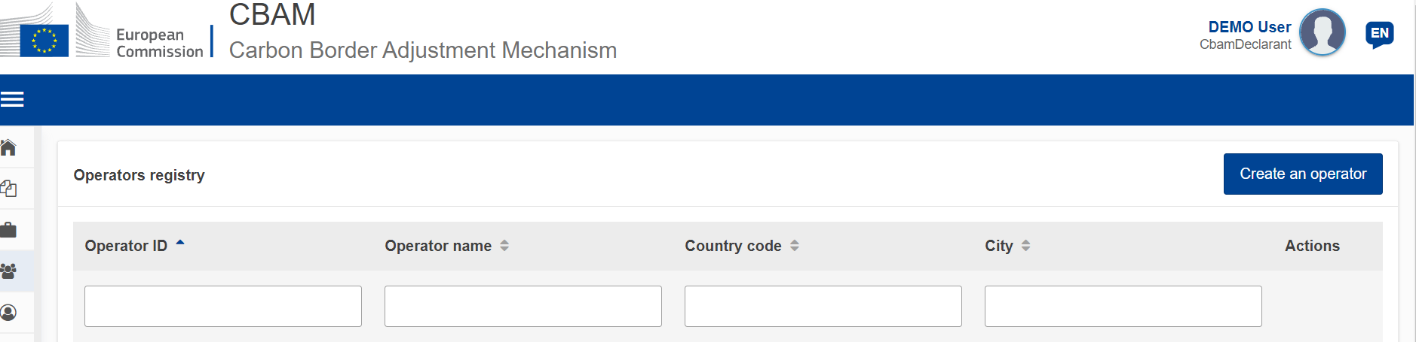
Figure 10 Operator - Create
- Fill in information in the operator card details. Ensure to utilise Latin characters (alpha numeric).
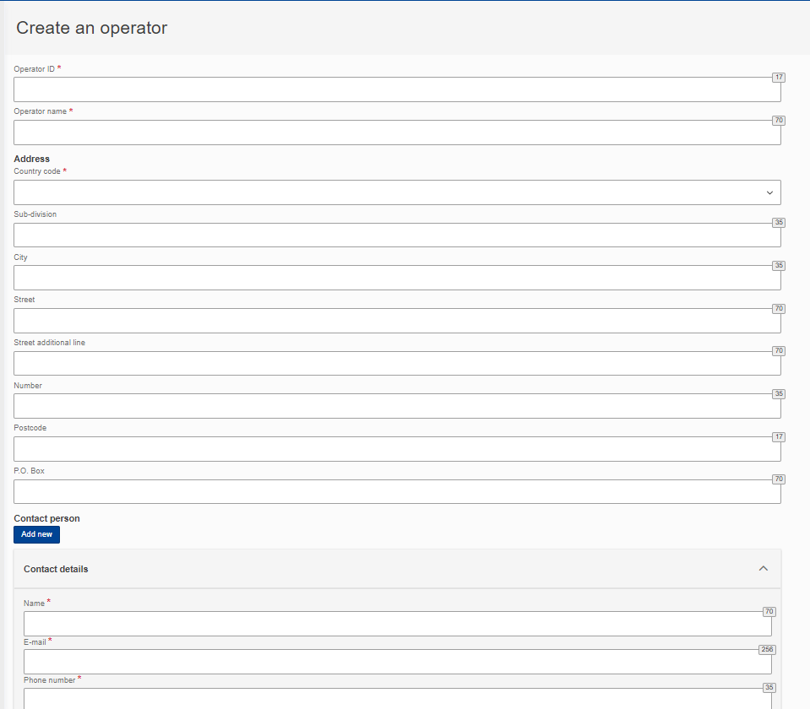
Figure 11 Operator Details Screen

- Please ensure that mandatory fields (marked with a red asterisk) are filled in as a minimum. When this is done, the “Create” button on the upper right corner will be enabled.
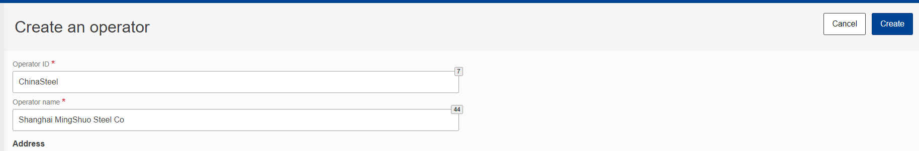
Figure 12 Create an Operator
- Once the operator is created, it will be listed in Operators Registry.
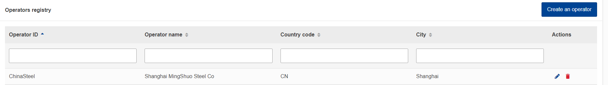
Figure 13 Operators Registry

Delete an operator
In the operator’s registry,
Figure 14 Operator Registry - Delete action.
when the icon is clicked for a specific operator, a confirmation message will appear to confirm the action to delete the operator.
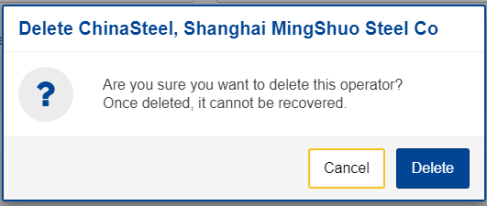
Figure 15 Operator Delete - Confirmation message.
To proceed with the operator deletion, the “Delete” button needs to be clicked in the confirmation message.

Edit an operator
In the operator’s registry,
Figure 16 Operators' registry

when the icon is clicked for a specific operator, the operator details screen will open. When changes are completed, the “Save” button needs to be clicked to save the updated operator information. In case, changes are not required, the “Cancel” button needs to be clicked.
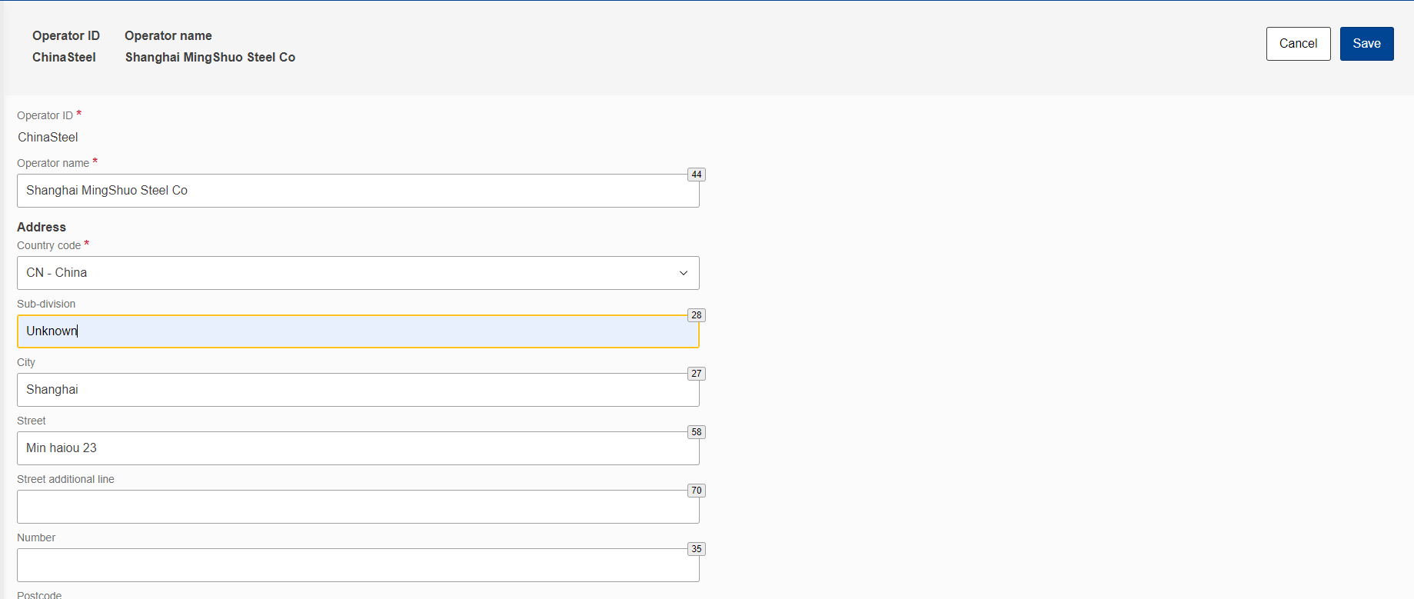
Figure 17 Operation - Save & Cancel

Installations Registry
CBAM System allows to store information for production installations in third countries. It is suggested to store installations in Installation Registry to easily prefill the relevant information when a report is created.

Create an installation
- Open the "Installations Registry" either by clicking on "Installations" icon from the Home Page dashboard or by clicking on "Installations" link in the left side navigation menu.
- Click the “Create an installation” button on the upper right corner.
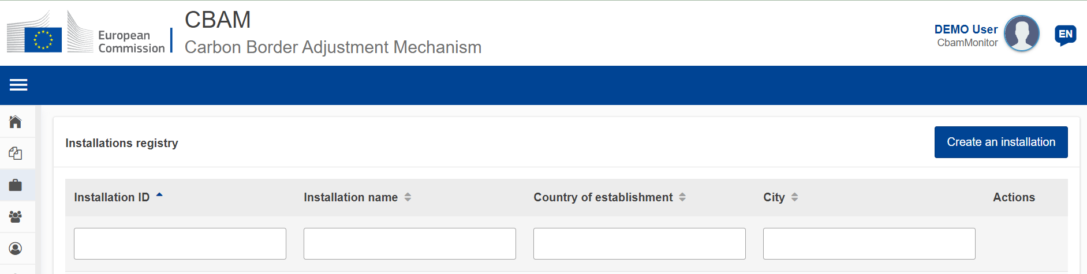
Figure 18 Installations Registry
- Fill the information in the installation card details. Ensure to utilise Latin characters (alpha numeric).
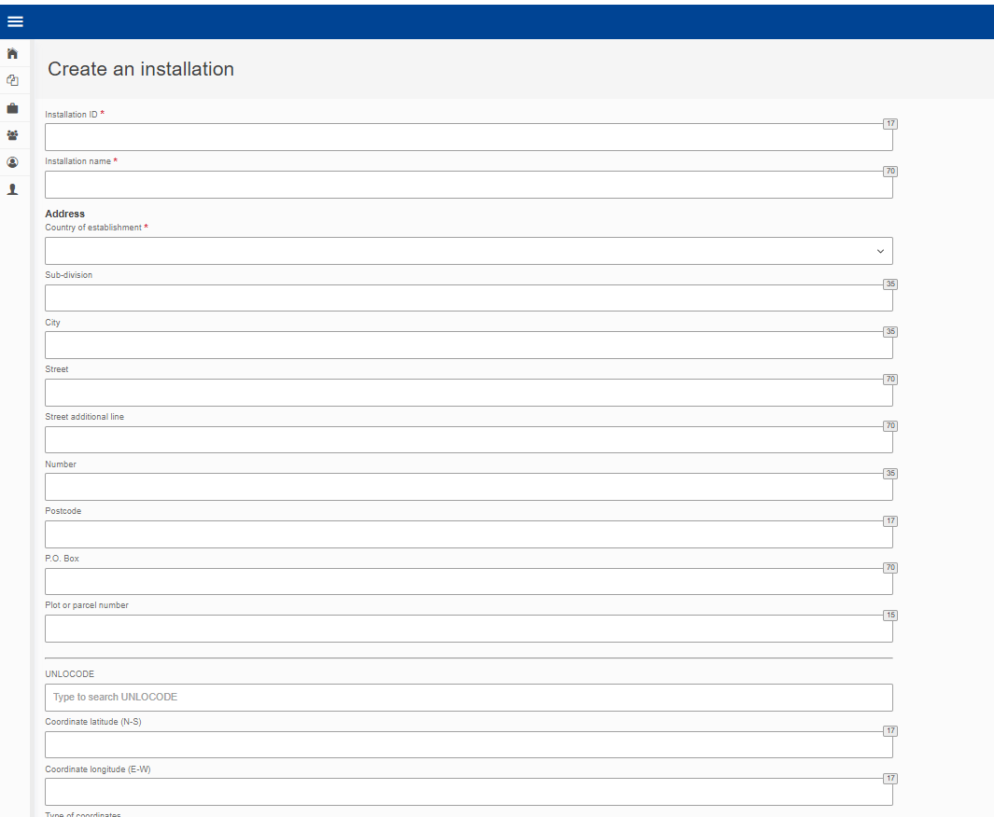
Figure 19 Installation - Details
- All mandatory fields marked with red asterisk need to be filled in.
- An installation needs to be linked with an operator. To accomplish this, click the “Search in third country installation operators registry”.
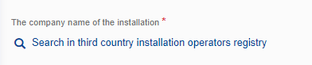
Figure 20 Installation-Search in third country installation operators registry
- The operators already created in Operators’ registry will be listed. The list can be filtered by operator ID, Operator name, Country code, city.
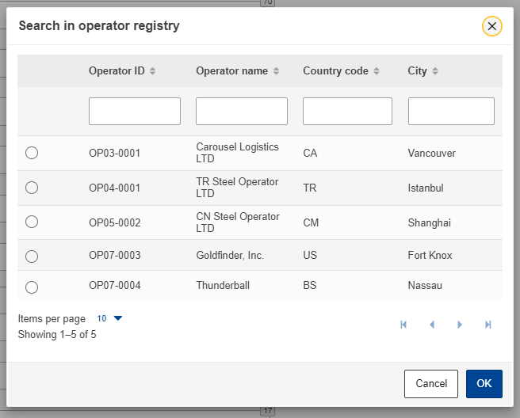
Figure 21 Search in operators registry
- Select the required operator. Click on the bullet on the left and it will change to
- Click the “OK” button on the right bottom corner of the operator registry dialog.
- The relationship between the installation and operator has been established and the operator’s details will be listed
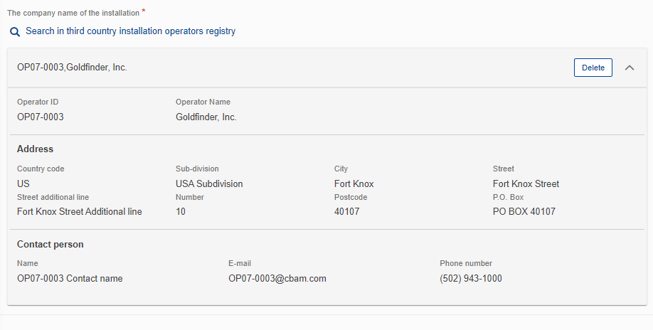
Figure 22 Installation - Linked Operator Details
- The “Create” button is now enabled on the upper right corner.
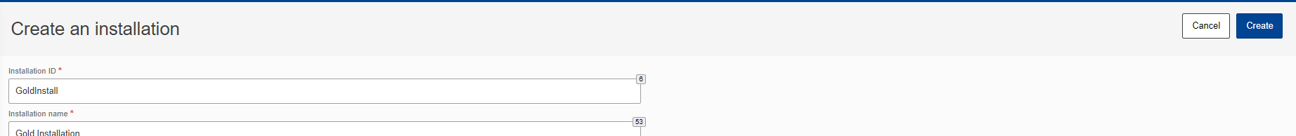
Figure 23 Installation - Create Button

- Once the installation is created, it will be listed in installations’ registry.

Delete an installation
In the installations registry,
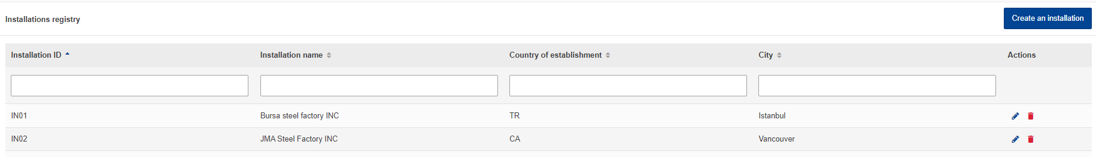
Figure 24 Installation Registry -Delete action
when the icon is clicked for a specific installation, a confirmation message will appear to confirm the action to delete the installation.
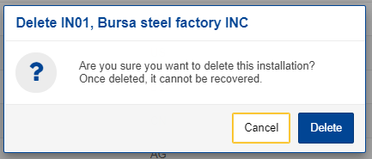
Figure 25 Installation Delete - Confirmation message.
To proceed with the installation deletion, the “Delete” button needs to be clicked in the confirmation message.

Edit an installation
In the installations registry,
Figure 26 Installation Registry - Edit Action
when the icon is clicked for a specific installation, the installation details screen will open. When changes are completed, the “Save” button needs to be clicked to save the updated operator information. In case, changes are not required, the “Cancel” button needs to be clicked.

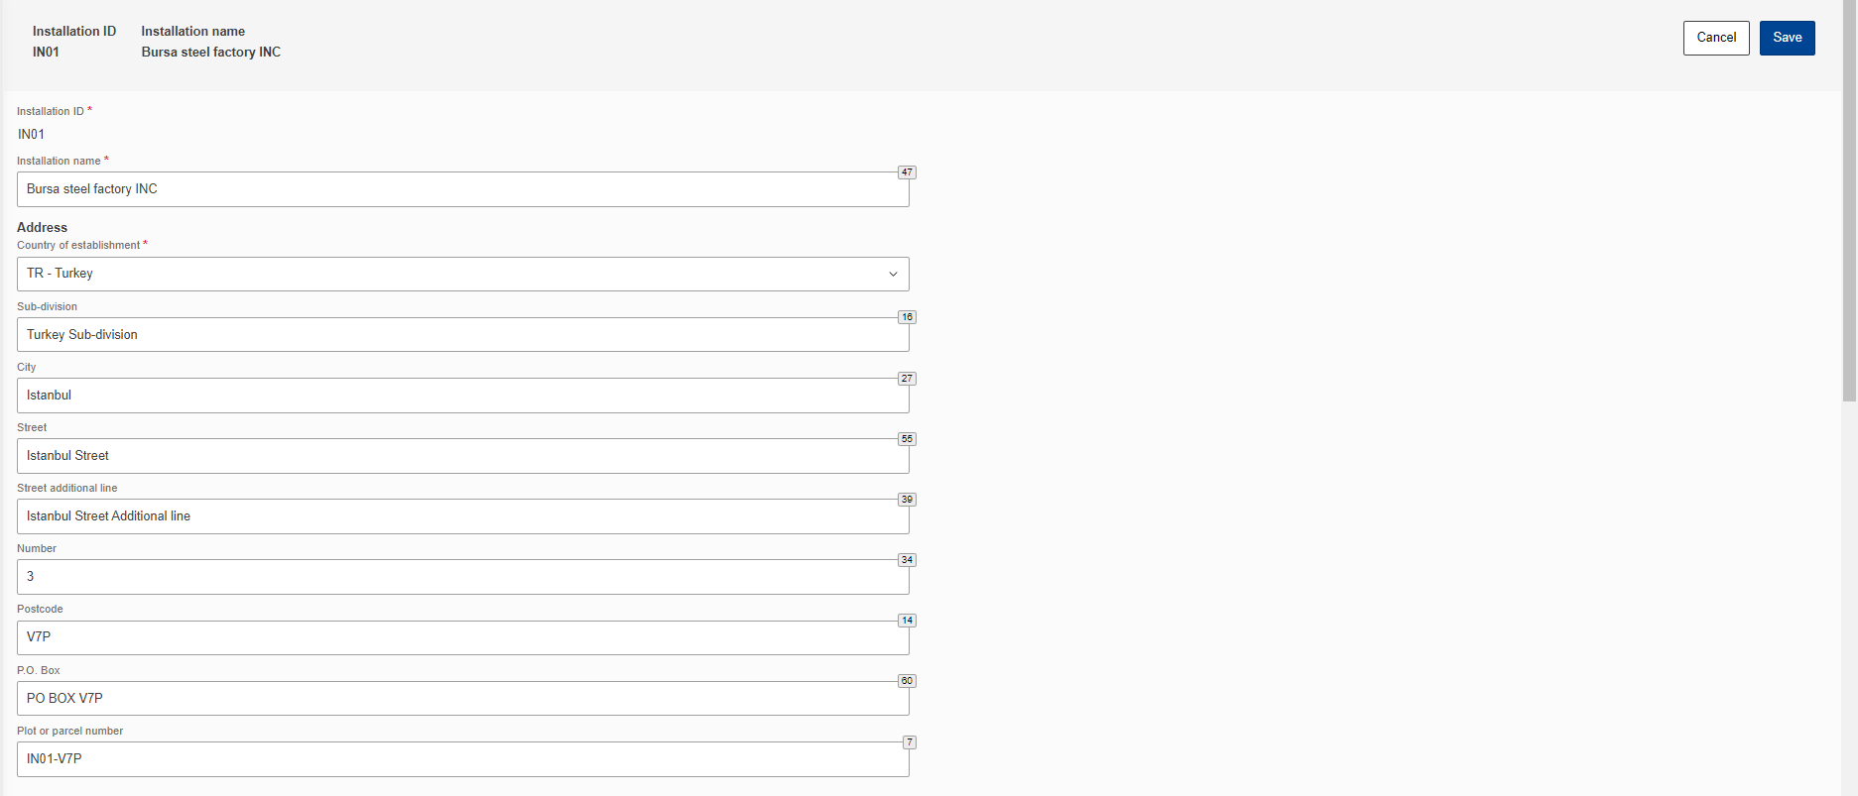
Figure 27 Installation -Cancel and Save buttons.

My quarterly reports
In this section, the Reporting Declarant can see a table organised per quarters of the year. For each quarter, there might be a CBAM report or not. If a CBAM report exists, then the Reporting Declarant can view it. If no CBAM report has been created, and the reporting period is open for submission of CBAM reports, then the Reporting Declarant can create their report or upload it in XML format with attachments packaged in a ZIP file.
If no CBAM report has been created and the reporting period is closed for CBAM reports submission, please follow the process 4.5.11 Request to submit a report with a delay.
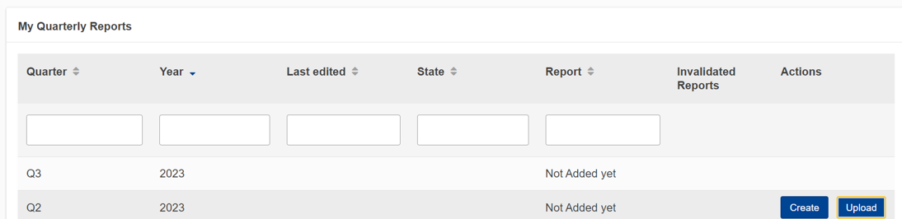
Figure 28 My Quarterly Reports

Report Structure & Navigation
The CBAM quarterly report structure consists of three main sections:
- The Report’s header section where the basic information for the CBAM Reporting Declarant and the reporting period are entered.
- The CBAM goods imported section, where the CBAM goods codes imported during the reporting period, along with information regarding their quantities, countries of origin and areas of import are declared in an aggregated way per CN code.
- The goods emissions section, where data regarding the CO2 emissions and the emissions qualifying parameters to produce each CBAM good added in the report and any supporting documents, are declared per installation and per production method.

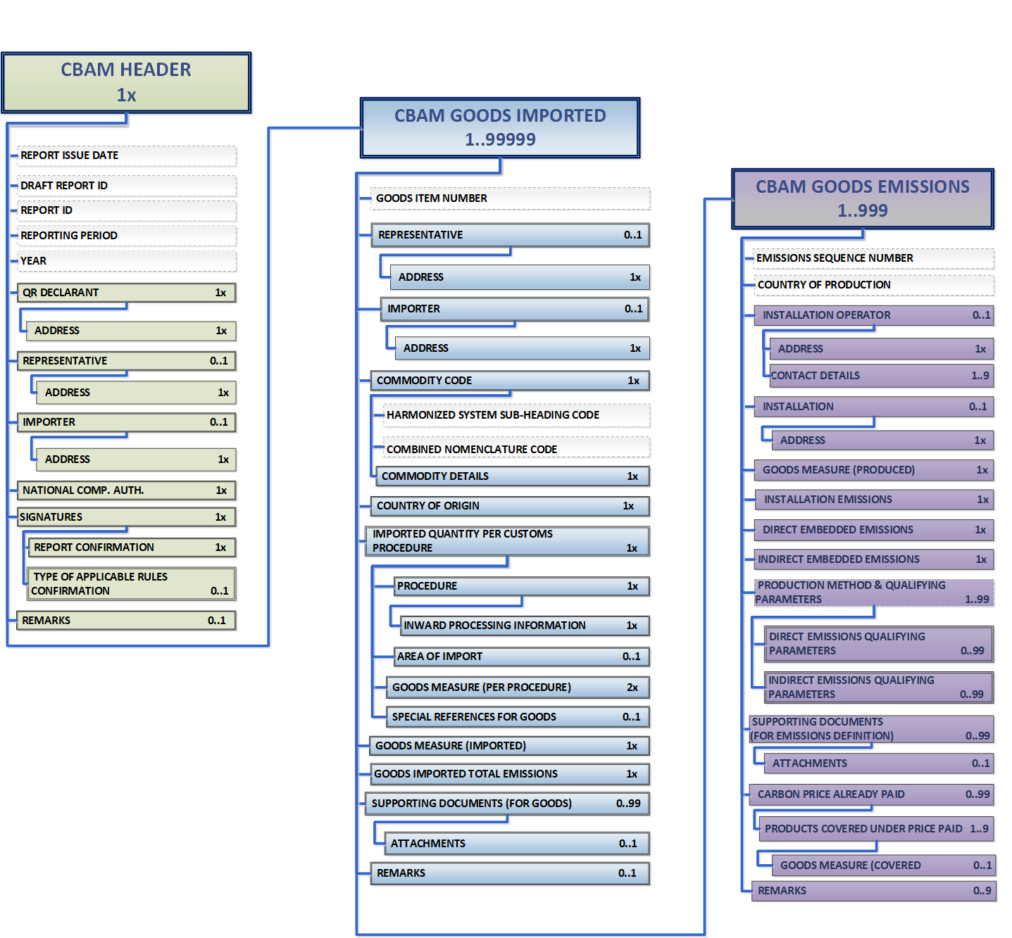
Figure 29 CBAM Report Data Model
Each of the above sections is comprised of the data groups and of the data elements available to be filled in, along with their cardinality, optionality, rules, conditions and code-lists that are applicable for each data. It is to be noted that the hierarchical structure of the data element needed for the report is following the Customs declaration approach as used in the Trans-European Customs systems and provides the advantage to the CBAM Reporting Declarants to declare the emissions and the supporting information for the CBAM goods imported in a familiar and efficient way. The report’s structure can also support the submission of supporting documents as binary attachments along with the report. The accepted file formats are: DOC, DOCX, XLS, XLSX, XML, PDF and JPEG.
Please note that the report can be filled in with one of the two following ways:
- Using the CBAM Reporting Declarant Portal user interface available.
- Uploading a ZIP file containing the XML structure of the report along with the binary attachments.
Instructions on how to fill each section of the report follows below.

Header level of the CBAM Report
Report general information is stored in the header.
Please save the header prior to start filling the goods & emissions section. As a minimum a draft report ID is required to be filled in (upper left corner). Please note that when the “Validate” button is clicked, the relevant validation errors that need to be addressed are displayed in each tab.
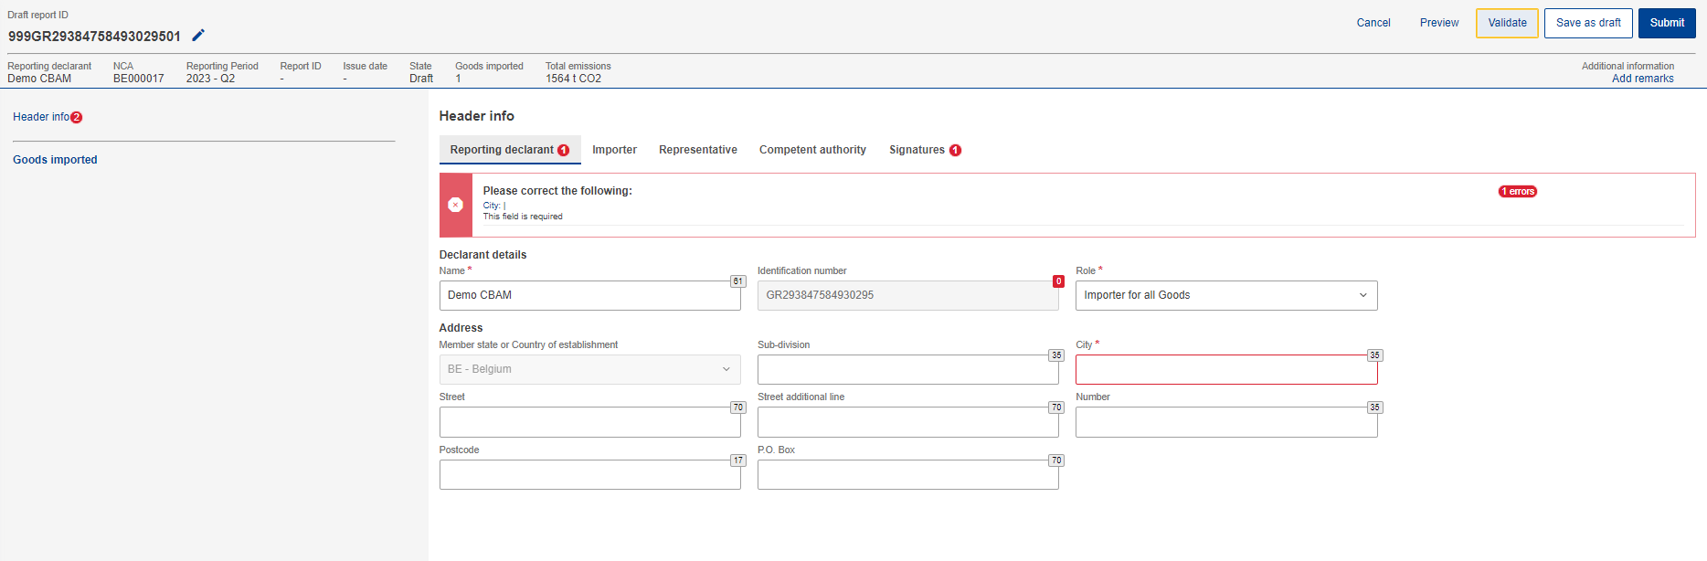
Figure 30 Header - Validation
The “Preview” button can be used to preview all values that are filled in header.
A detailed description of each tab is available below.

Reporting Declarant
Reporting Declarant Name, Identification number and Member state of establishment, are filled in automatically.
The rest Reporting Declarant information need to be filled in. As a minimum, the “Role” and “City” fields need to be defined in “Reporting Declarant tab”.
The Reporting Declarant role is a mandatory field. Here is an explanation for each option.
Importer for all goods - In case the Reporting Declarant acts as an importer for all goods, the “Importer tab” in the header level and goods level is not required to be filled.
Representative for all goods - In case the Reporting Declarant acts as a representative for all goods, the “Representative tab” in the header level and goods level is not required to be filled.
Importer for some goods/ Representative for some goods – The importer / representative is required to be defined at each good level.
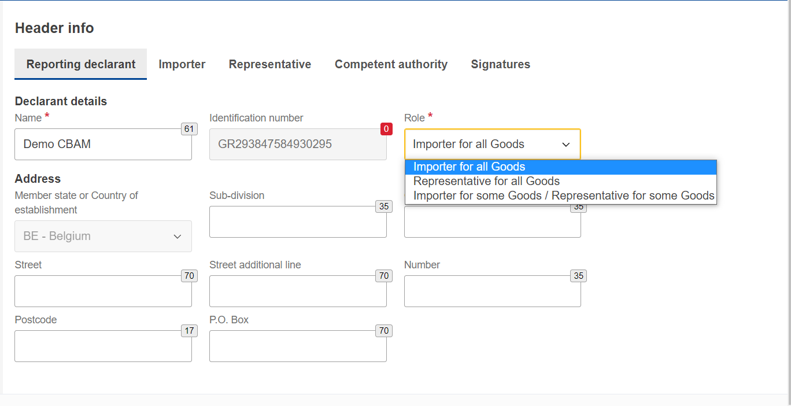
Figure 31 Header - Reporting Declarant tab

Importer
If an importer is defined in Header level of CBAM Report, it will be applied for every good item. If the report includes multiple importers, they need to be defined separately for each good.
In case the Reporting Declarant is the importer for all goods, the checkbox “Reporting Declarant acts as importer” could be checked to avoid filling in the same information again.
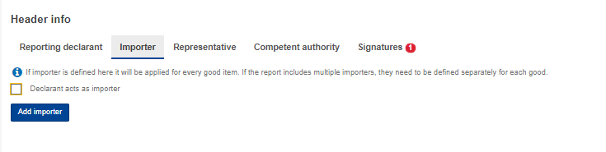
Figure 32 Declarant acts as importer Checkbox
However, if the importer is not the same as the Reporting Declarant, then the “Add importer” button should be clicked to fill in importer’s information.
Importer’s details will be deleted from header level of CBAM Report if the “Delete” button is clicked.
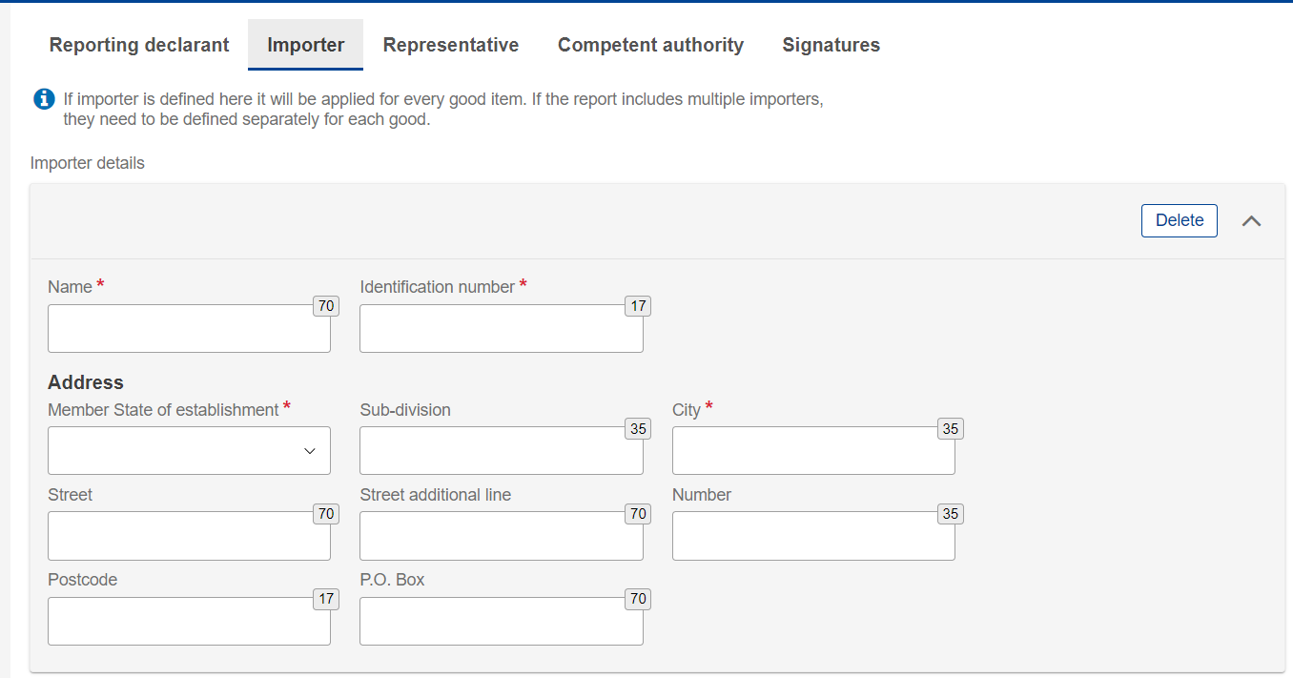
Figure 33 Header- Importer tab

Representative
If a representative is defined in Header level, it will be applied for every good item. If the report includes multiple representatives, they need to be defined separately for each good.
In case the Reporting Declarant is the importer’s representative for all goods, the checkbox “Reporting Declarant acts as representative” could be checked to avoid filling in the same information again.
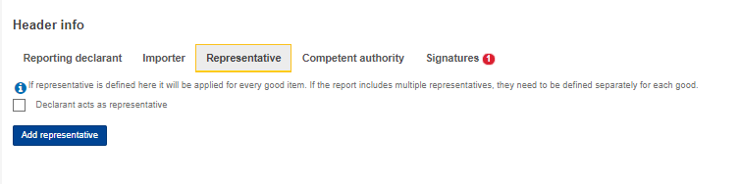
Figure 34 Declarant acts as representative checkbox
However, if the representative is not the same as the Reporting Declarant, then the “Add representative” button should be clicked to fill in representative ‘s information.
Representative’s details will be deleted from header if the “Delete” button is clicked.
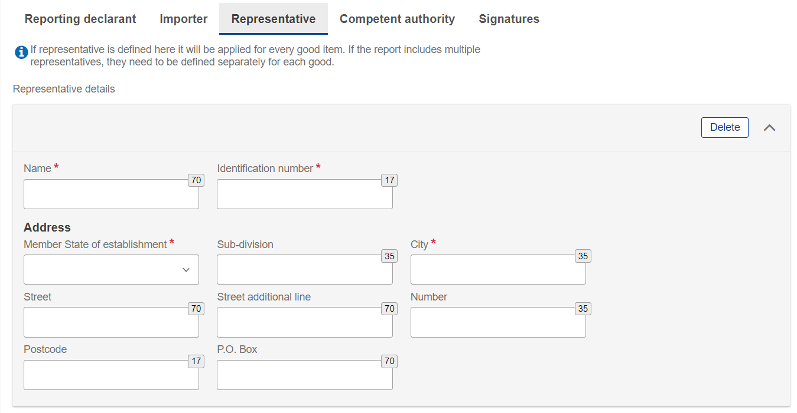
Figure 35 Header - Representative Tab

Competent authority
Competent Authority reference number is automatically filled in based on the country the Reporting Declarant’s EORI number belongs to.
In case it is not filled in automatically, please contact your respective National Competent Authority Service Desk.

Signatures
All fields of this tab are mandatory to be filled to allow report submission.
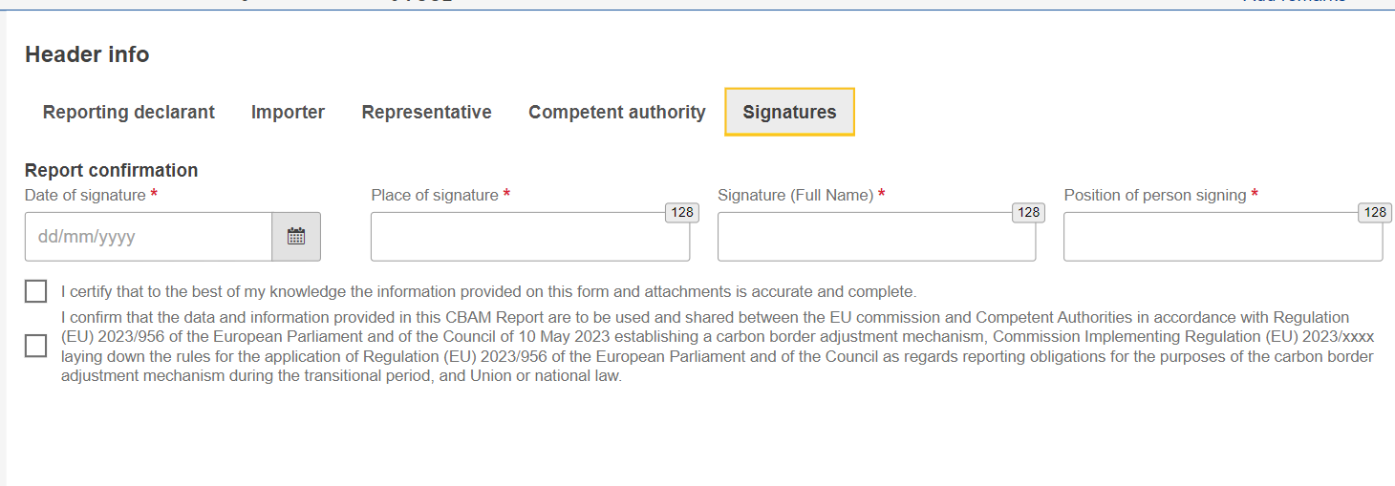
Figure 36 Header -Signatures tab

CBAM goods Level of the CBAM Report
By clicking on “Goods imported”, the user can add as many goods as desired or/and navigate through a list of all goods that have been added. Please note that at least one good must be declared and added in the report.

Add good
The user can add a good by clicking the “Add a good” button, either from the navigation tree on the left or using the button above the table.
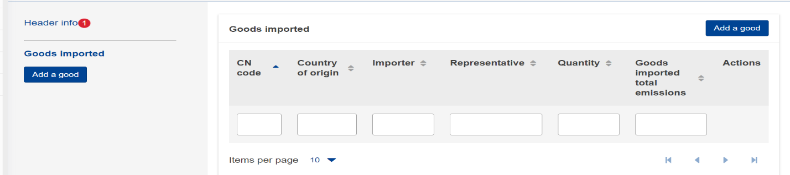
Figure 37 Add good

Delete good
The user can delete a good by clicking the 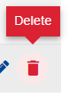 delete icon in the action column in good’s table.
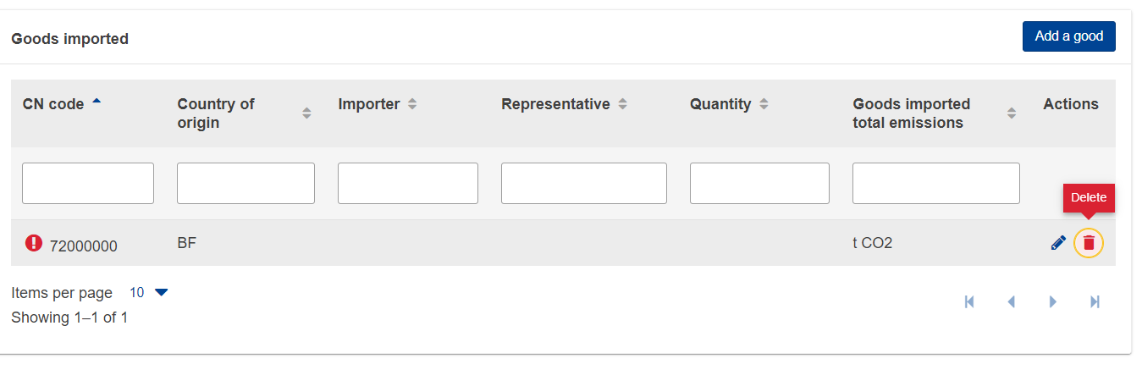
Figure 38 Delete good
A confirmation message will appear to confirm the user action prior the good’s deletion.
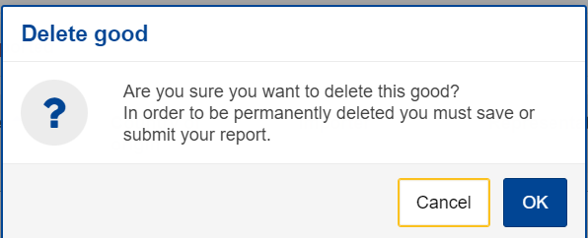
Figure 39 Delete good -Confirmation

Edit good
Once the user is in Editing mode in the report, the good can be edited either by clicking the respective good on the left navigation tree or by clicking the Edit icon on the good’s table.
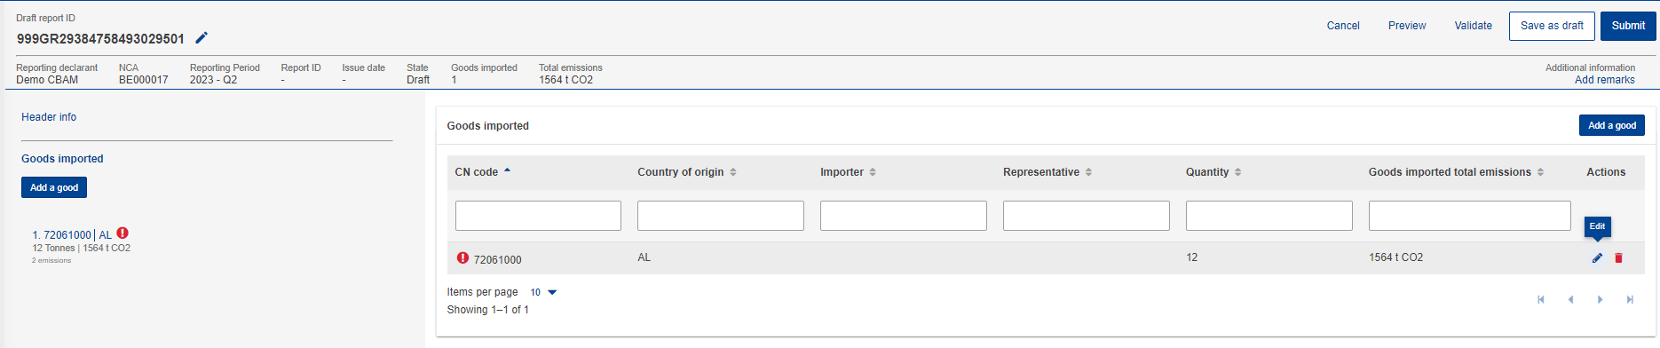
Figure 40 Edit good

Save good
Please ensure to save each good prior to adding/editing other good by clicking the “Save” button.

Validate good
The user shall validate separately every Good Imported along with its emissions. After completing the insertion of information, the "Validate" button in “Action menu” must be clicked so that the validation is performed. Possible errors in the validation are shown with a red exclamation mark icon. In order to validate it, edit the respective good and click the Validate button on the Action Menu.
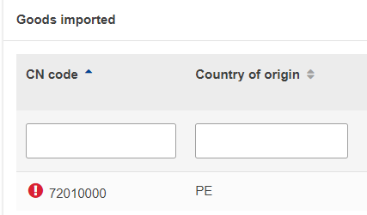
Figure 41 Non-validated good

When the “Validate” button is clicked, validation errors are generated on the good’s level and for each emission added.
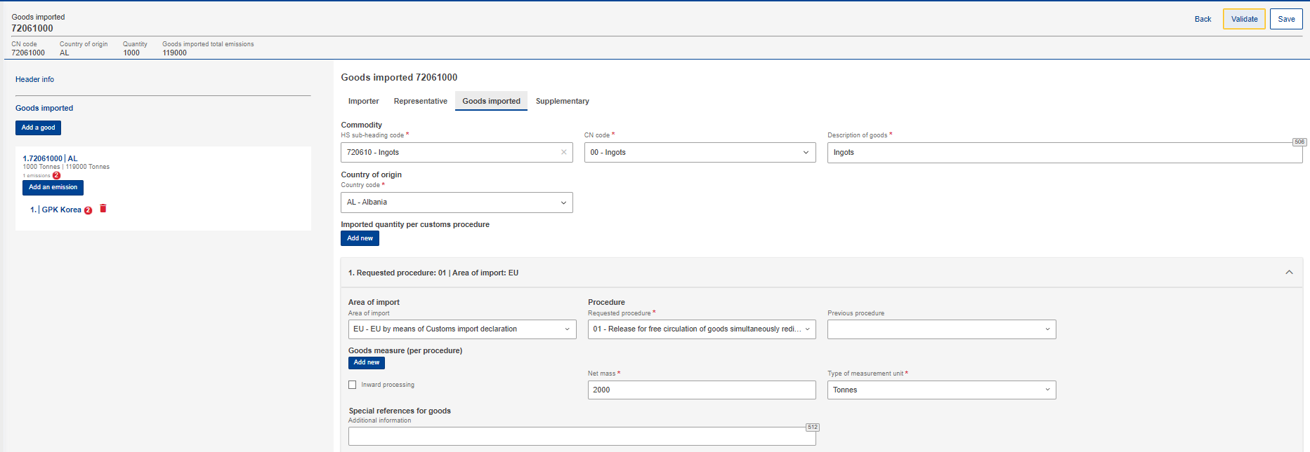
Figure 42 Validate Good
In the navigation tree on the left the number of messages that need to be addressed are displayed.
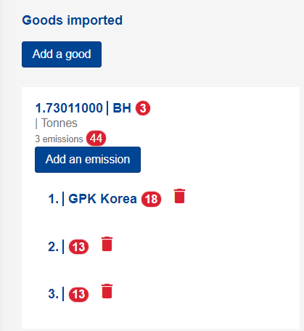
Figure 43 Validate good – Navigation tree indication

How to fill in the good
The following sections are describing how to fill in the details in each tab.

Importer
In the “Importer” tab, the user can check the box appearing in case the Reporting Declarant acts as importer or click on the “Add importer” button to add importer details. If an importer is defined in the Header level, the respective tab in the good’s imported level will not appear, otherwise the tab is mandatory to be filled in.
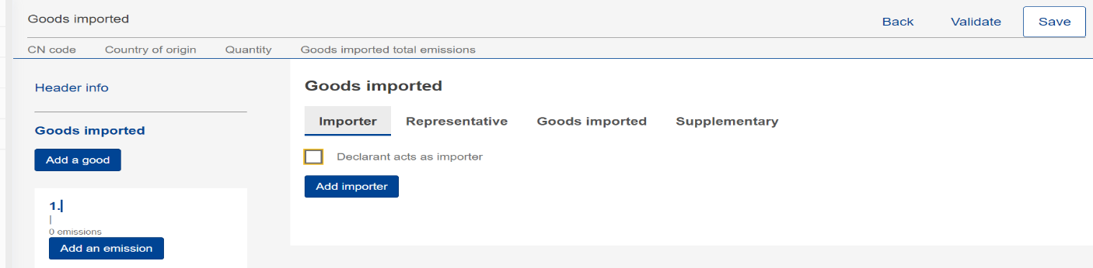
Figure 44 Good Level - Importer tab

If the user hits the “Add importer” button then he/she can add details of the importer on the appearing menu, where all fields marked with an asterisk are mandatory.
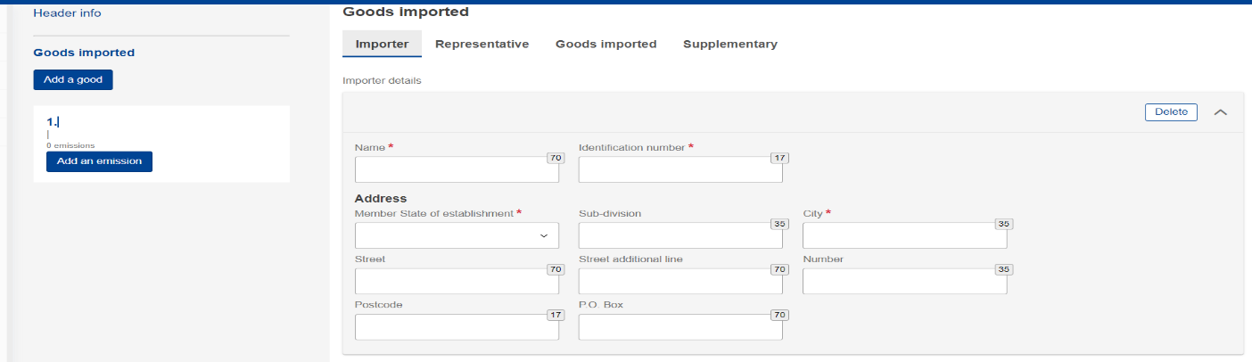
Figure 45 Good Level - Add Importer
If the user needs to delete an importer, he/she can click the “Delete” button on the up-right corner of the menu.

Representative
In the “Representative” tab, the user can check the box appearing in case the Reporting Declarant acts as representative or click on the “Add representative” button to add representative details.
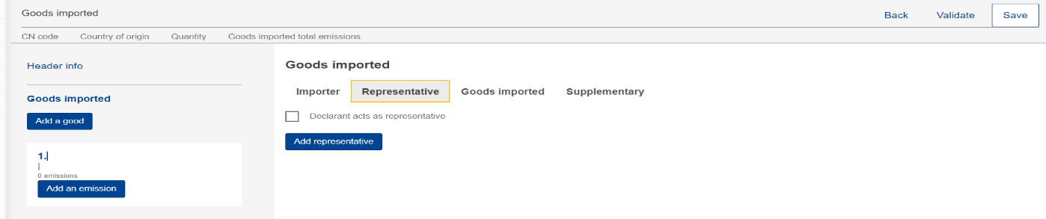
Figure 46 Good’s level - Representative tab

If the user hits the “Add representative” button then he/she can add details of the representative on the appearing menu, where all fields marked with an asterisk are mandatory.
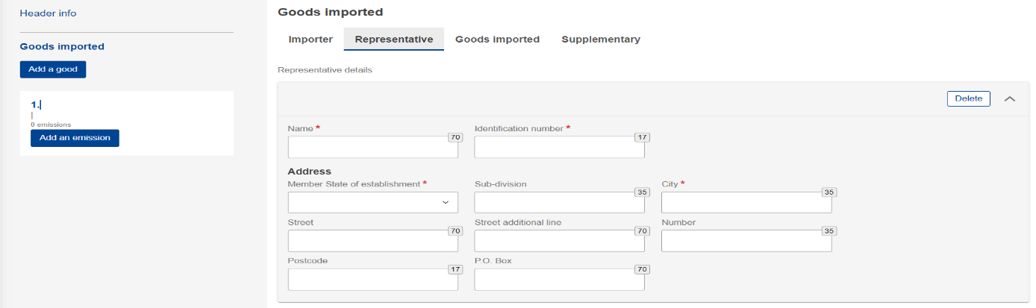
Figure 47 Good’s level - Add Representative

If the user needs to delete a representative, he/she can click the “Delete” button on the up-right corner of the menu.

Goods Imported
In “Goods imported” tab, the user must fill in all the mandatory fields marked with an asterisk.
After adding the HS and the CN codes, the “Description of goods” is automatically filled in. Please note that a minimum of 2 characters are required in HS sub-heading code to allow the system to display the available CBAM goods.
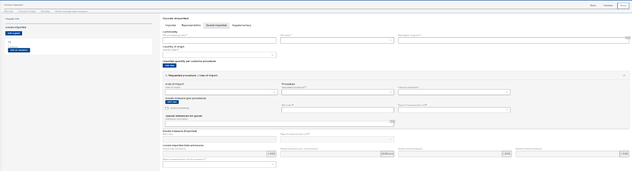
Figure 48 Goods imported tab

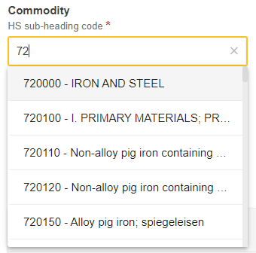
Figure 49 HS sub-heading code selection

By clicking the “Add new” button right below the “Imported quantity per customs procedure” line, the user can add more than one quantity of goods imported in case the customs procedure differs from one import procedure to another import procedure.
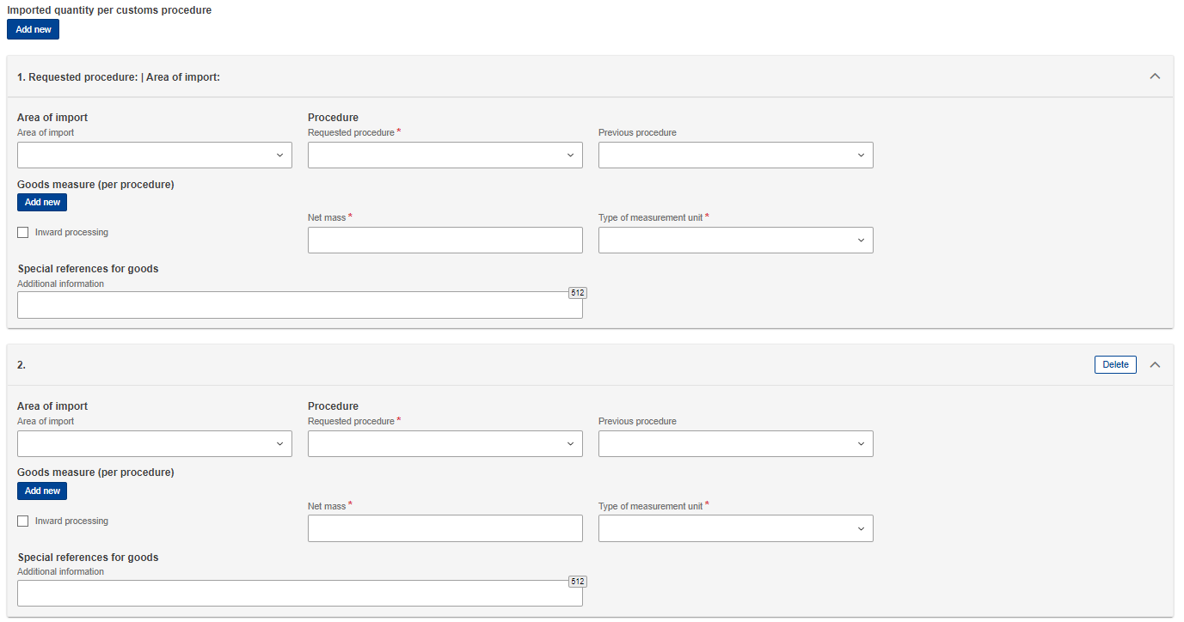
Figure 50 Imported quantity per customs procedure
Please note that goods Imported total emissions, goods emissions per unit of product, goods Direct Emissions and goods indirect emissions will be filled in automatically based on the emissions information to be added for each good.
In case the previous procedure is inwards processing, by clicking the “Add new” button right below the “Goods measure (per procedure)” line, the user can add more than one measure of goods.
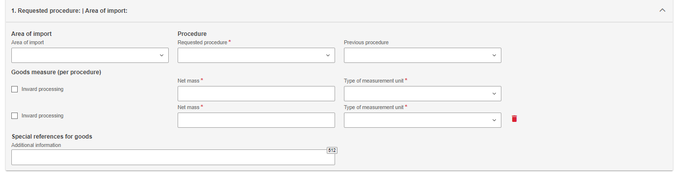
Figure 51 Goods measure per procedure

Supplementary
In “Supplementary” tab, the user can add information about the good in the textbox or/and add “Supporting” documents by clicking the “Add new” button.
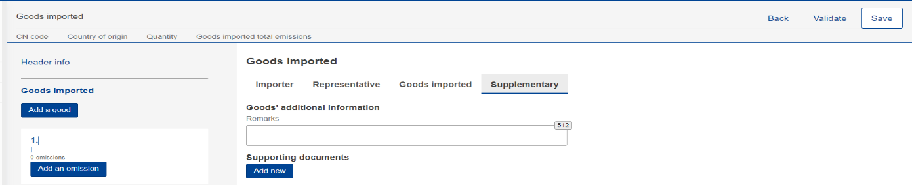
Figure 52 Goods - Supplementary tab

By clicking the “Add new” button, the user needs to fill in the fields marked with an asterisk as they are mandatory. If the user needs to delete the supporting document, he/she can do so by clicking the “Delete” button on the upper right corner of the menu.
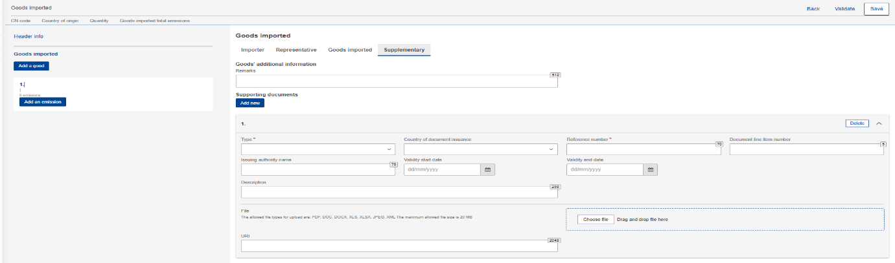
Figure 53 Goods - Add supporting documents.

Emissions level of CBAM report
For each CBAM good added in the report, its respective emissions need to be declared. Multiple emissions can be added based on installation/country of production.

Add Emissions
Press the “Add an emission” button the left side of the screen to get the process started. For each emission added, an incremental number will be shown automatically.
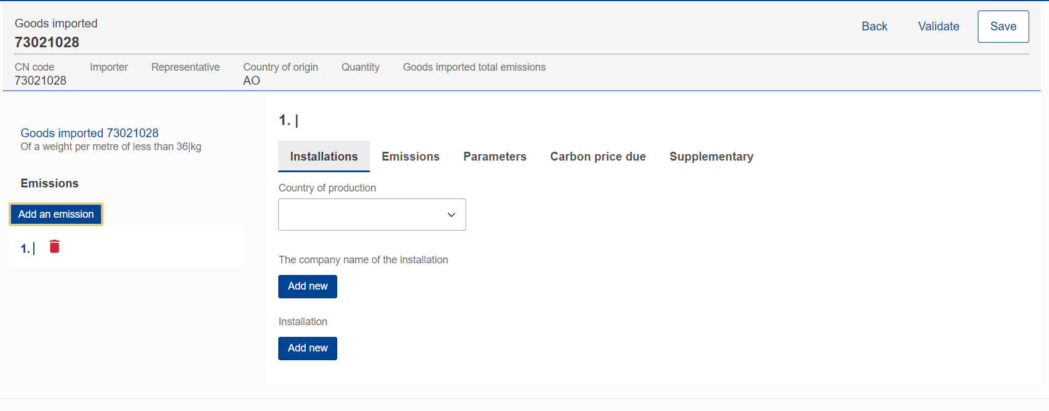
Figure 54 Add an emission.

Delete Emissions
In order to delete an emission data elements group, click thenext to emission sequence number.
Figure 55 Delete emission.

Edit Emissions
Emissions can be edited once the related good is in edit mode, see 4.4.2.3 Edit good. In the left navigation tree, click the emission that needs to be edited. Please note that if “Save” button is clicked from the “Action menu” the good & emission information is saved and the good will need to be reopened to continue with emissions editing.
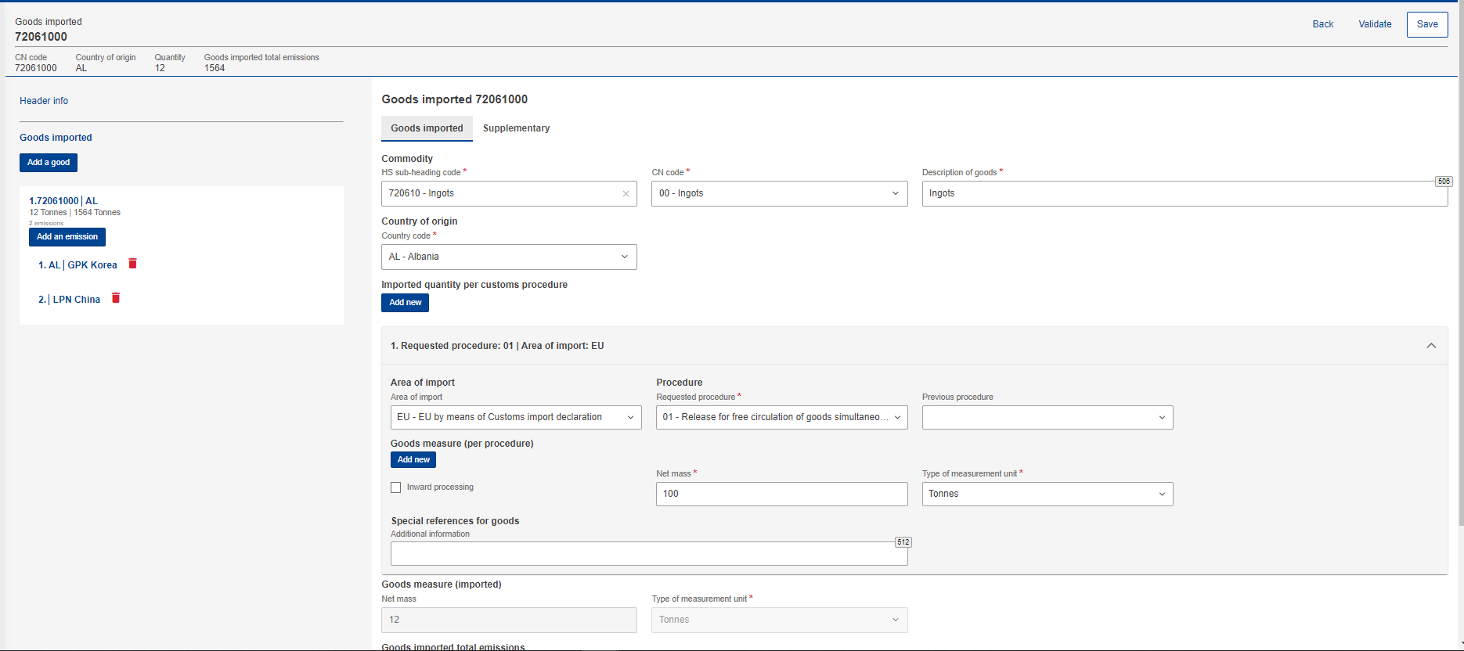
Figure 56 Edit good

How to fill in the emissions
The following sections will describe each screen tab in detail.

Installations
In this tab the following information need to be defined: Country of production, Operator (Company that owns the installation), and Installation.
Operator & Installation are optional elements, however it is advisable to define them.
Country of production is mandatory to be defined (it should match the country of installation establishment if defined).
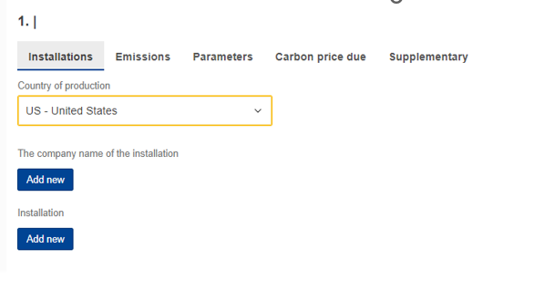
Figure 57 Installation - Country of production
The company name that owns the installation can be either be filled in directly in the report or selected from the Operators registry. (See section 4.1 Operators Registry). click the “Add New” button.
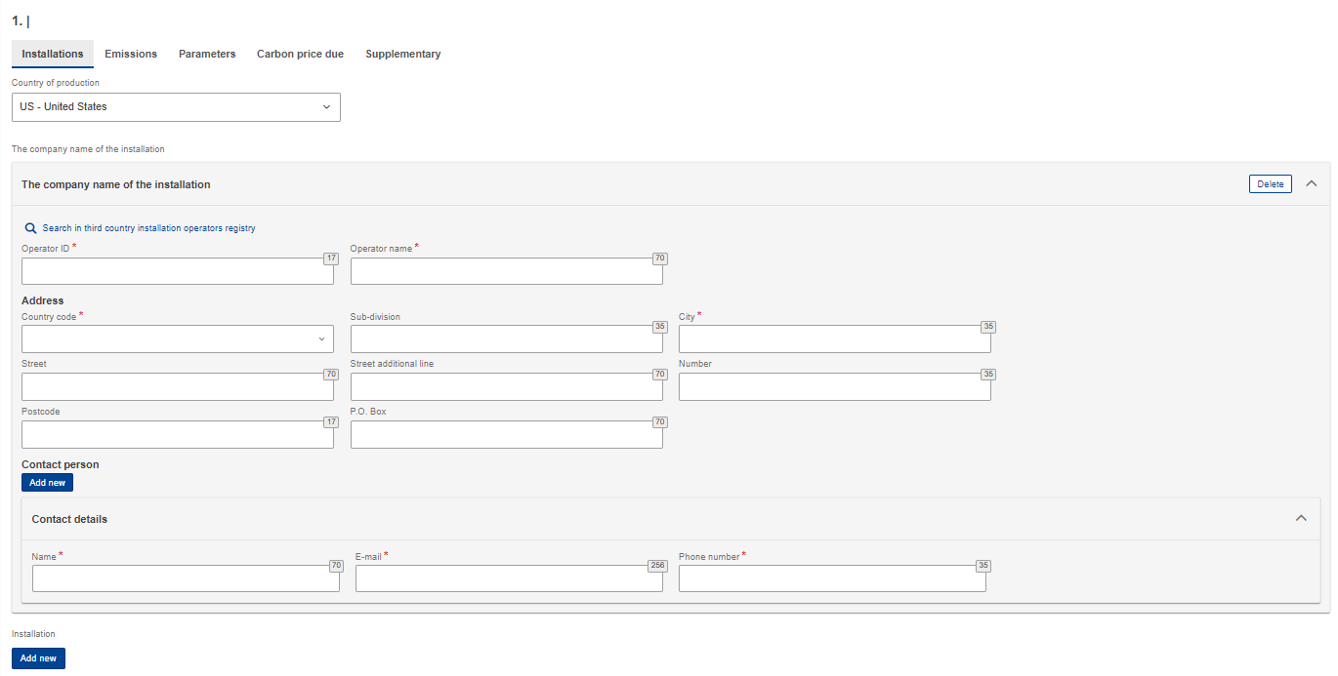
Figure 58 Emissions - Operator (The company name of the installation)
An operator can be selected from the operator’s registry by clicking the “Search in third country installation operators registry”.
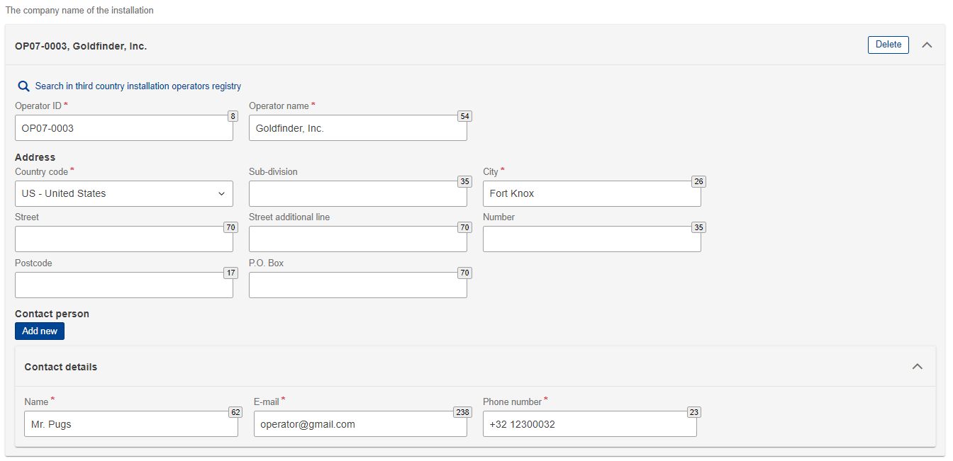
Figure 59 Emissions - Operator (Information filled in from Operator Registry)
Installation can be either filled in directly in the report or selected from the Installation registry. (See section 4.2 Installations respectively). click the “Add new” button.
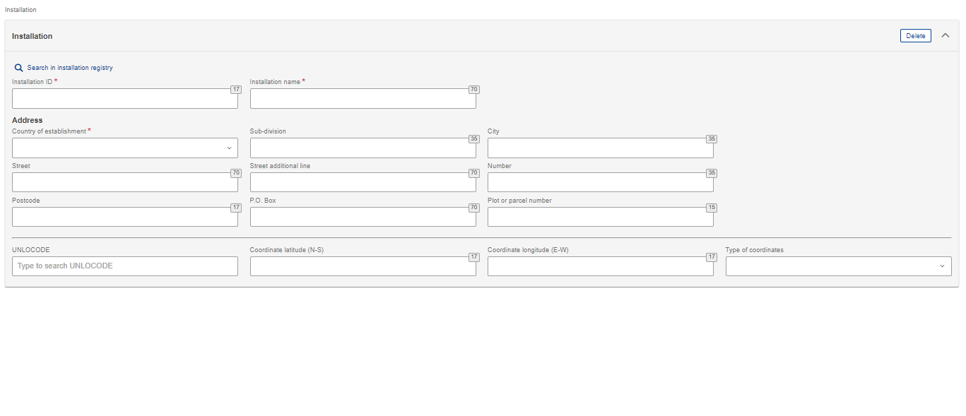
Figure 60 Emissions - Installation fields
An installation can be selected from the Installation registry by clicking the “Search in installation registry”. Please note that the installation available to be selected are the ones that have been associated with the operator selected.
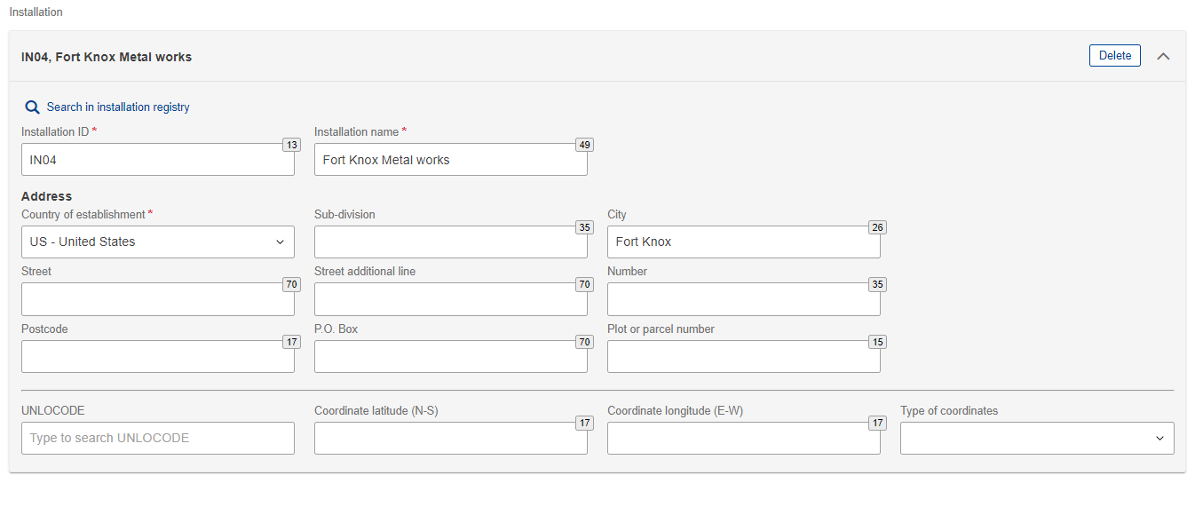
Figure 61 Emissions-Installation information filled in from Installations Registry

Emissions
The emissions tab will be differentiated when Electricity is selected in good’s section. Ensure to fill in all mandatory fields.
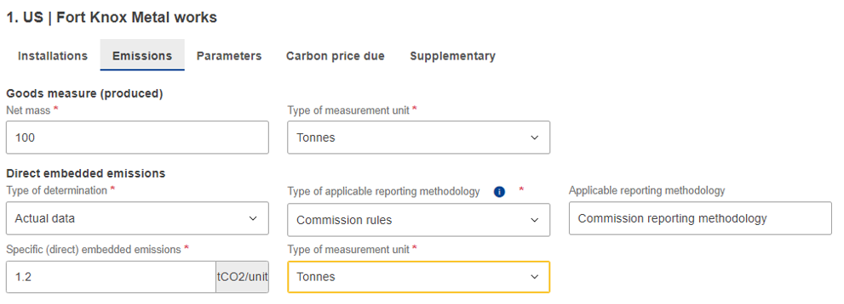
Figure 62 Emissions tab - Applicable to Electricity good
For all goods except electricity, both direct and indirect embedded emissions need to be defined. Based on type of determination, some fields make become read only.
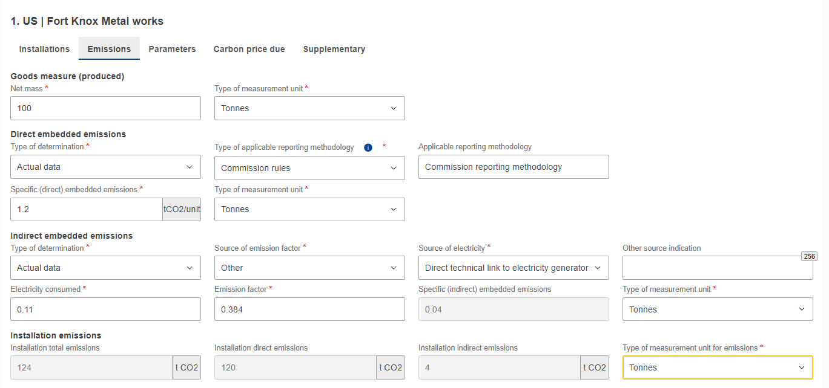
Figure 63 Emissions tab- Applicable for all goods except electricity

Parameters
This screen varies based on the good selected. It is not a mandatory screen to be filled in, however the information provided helps to justify the emissions calculated.
The first section is related to the production methods used. It is pre-filled based on data available in the for each CN Code.
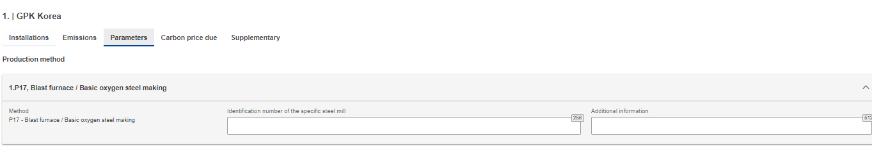
Figure 64 Production Method (sample)
In direct & indirect emissions qualifying parameters, the default qualifying parameters per production method are added (if available). For each qualifying parameter, the value & type of determination method needs to be added.
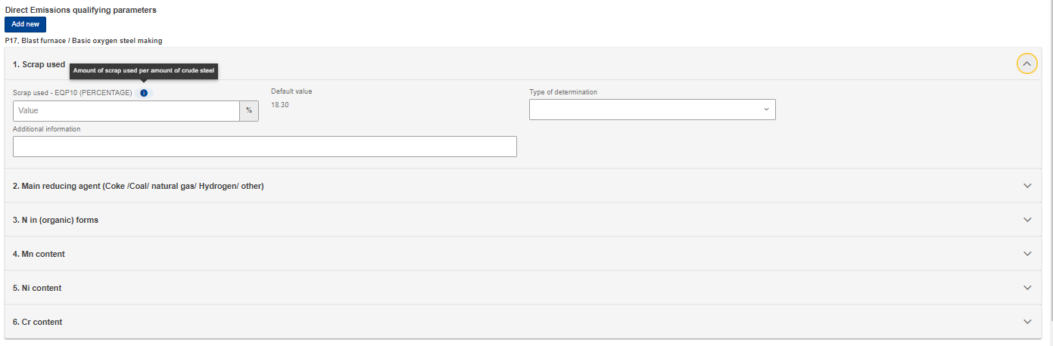
Figure 65 Direct emissions qualifying parameters
Click the “Add new” button to add other qualifying parameters.
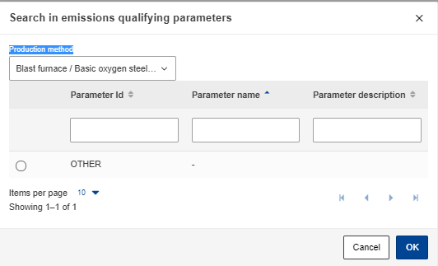
Figure 66 Add new qualifying parameters
Indirect emissions qualifying parameters are not required to be filled in when electricity is selected as good.
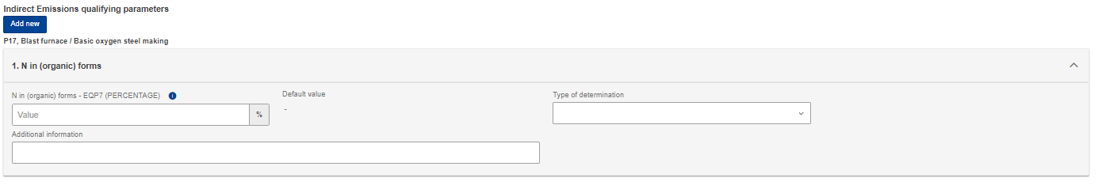
Figure 67 Indirect Emissions qualifying parameters

Carbon price due
This section is optional. In case CO2 emissions have already been paid in other countries, in this section all relevant information will be required to be filled in. The most important information to be provided is the national legal basis of the carbon pricing scheme including the implementing provisions and their respective sources.
Click the “Add New” button to start filling in the details. Please note that multiple sections can be added based on the country /type of instrument combinations.
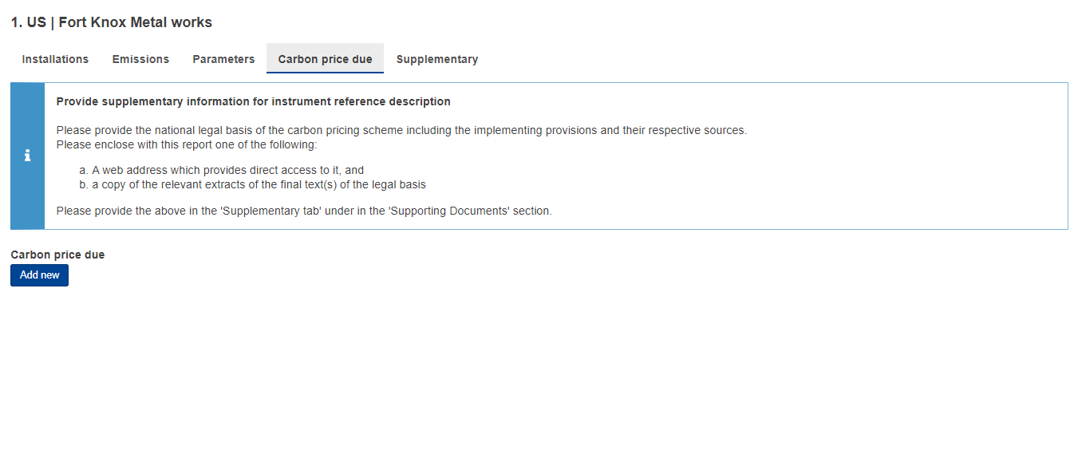
Figure 68 Carbon price due tab

For each country/type of instrument combination, multiple goods covered under carbon price due can be defined by clicking the “Add New” button below the “Goods covered under carbon price due” label.
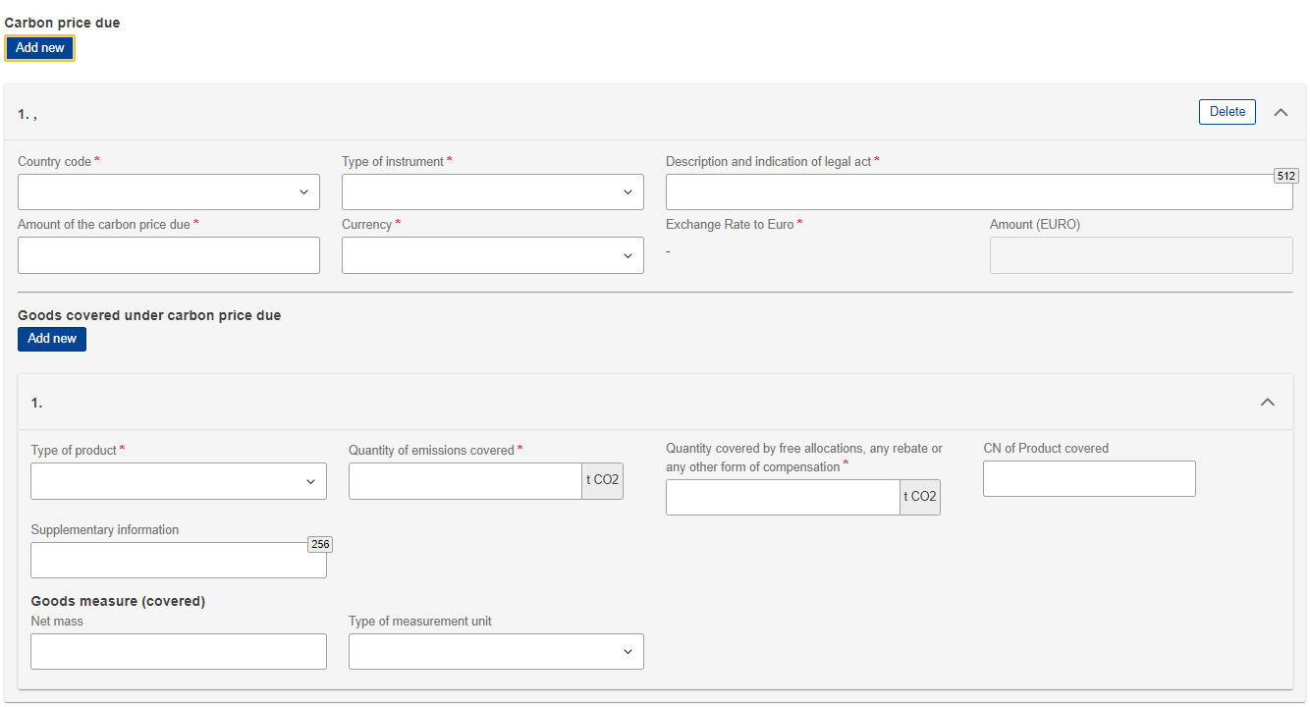
Figure 69 Carbon price due -Details
Please fill in all mandatory fields. Regarding exchange rates, these will be defined by the European Commission.

Supplementary
In this tab additional information for emissions calculations can be added and all supporting documents.
Multiple additional information & supporting documents can be added by clicking the “Add new” button.
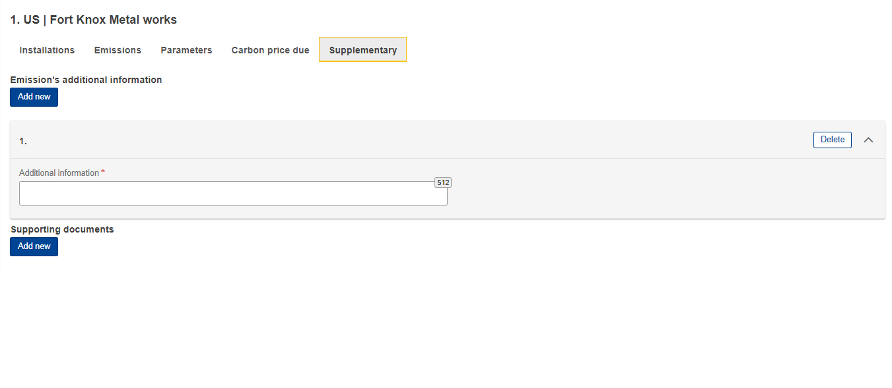
Figure 70 Supplementary tab
For each emissions supporting document, the type and Reference number are mandatory to be filled in. A document can be added either by using the “Choose File” or by dragging and dropping. In order to delete an uploaded file, the “Delete” button needs to be clicked.
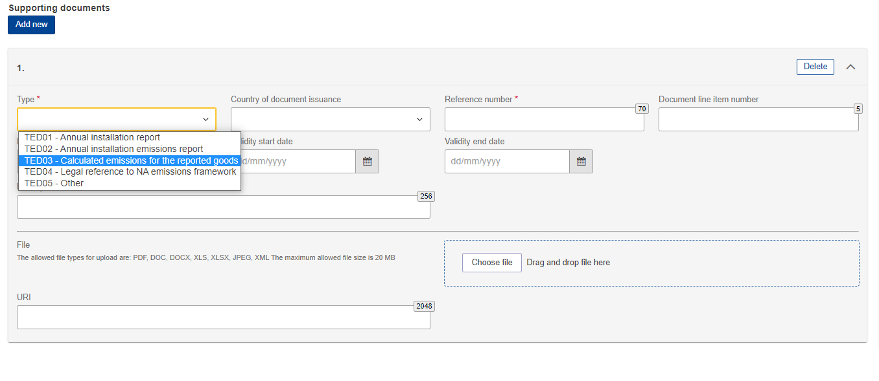
Figure 71 Emissions - Supplementary - Supporting Documents

Report actions
In this section all the processes related with the report management that a CBAM Reporting Declarant can perform will be listed in detail.

Create a report
In Home Page, click “My quarterly reports” and then click the “Create” button for the reporting period where a report needs to be created.
The “Create” button is visible only during the allowable reporting deadline. In the case a report needs to be created after the deadline expiration, please follow the process 4.5.11 Request to submit a report with a delay.
Figure 72 My Quarterly Reports - Create Report

Upload a report
Instead of using the user interface to fill in the report fields, an XML can be uploaded (in ZIP format containing all relevant attachments). The XML should be structured according to the XSD format listed in Annex 6.1 CBAM Report (XSD). A sample ZIP file is also included in 6.2 Sample ZIP file.
Click the “Upload” button of the report that needs to be filled in “My Quarterly Reports”.
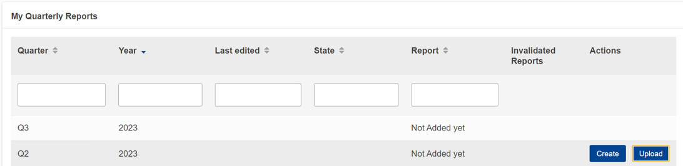
Figure 73 My Quarterly Reports - Upload a report.
In the upload ZIP dialog, you can choose the file to be uploaded or you can drag & drop the file.
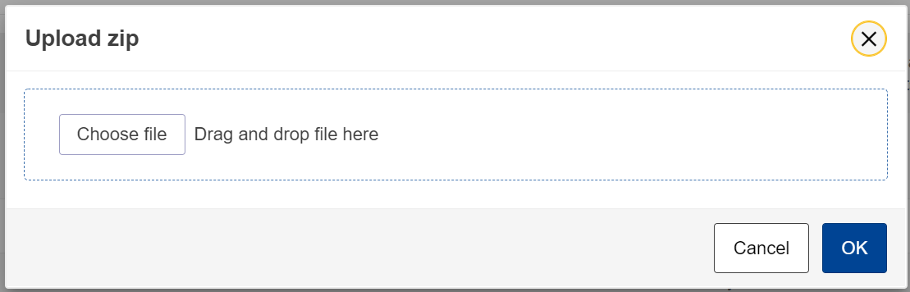
Figure 74 Upload ZIP

The “Upload” button is visible only for quarterly reports that their associated reporting period deadline has not expired. In case a report needs to be created after the deadline expiration, please follow the process 4.5.11 Request to submit a report with a delay.
Please note that once a report is uploaded it is not considered submitted. Please ensure to address any validation errors first.

Save a draft report
Once a report has been created, the “Save as draft” button needs to be clicked in order to save a draft Report. As a minimum a Draft Report ID needs to be defined which is in the upper left corner of the screen.
Additional validation rules may be generated during this process; however, these can be addressed at a later stage and before report submission.
Save as draft can be used as often as needed to save the contents of the report under preparation.
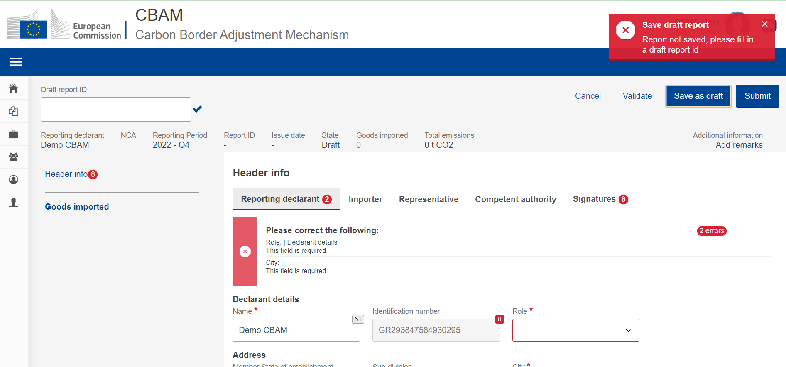
Figure 75 Save a draft report

Delete a draft report
A draft report can be deleted. The “Delete” button is available when the saved report is opened in view mode.
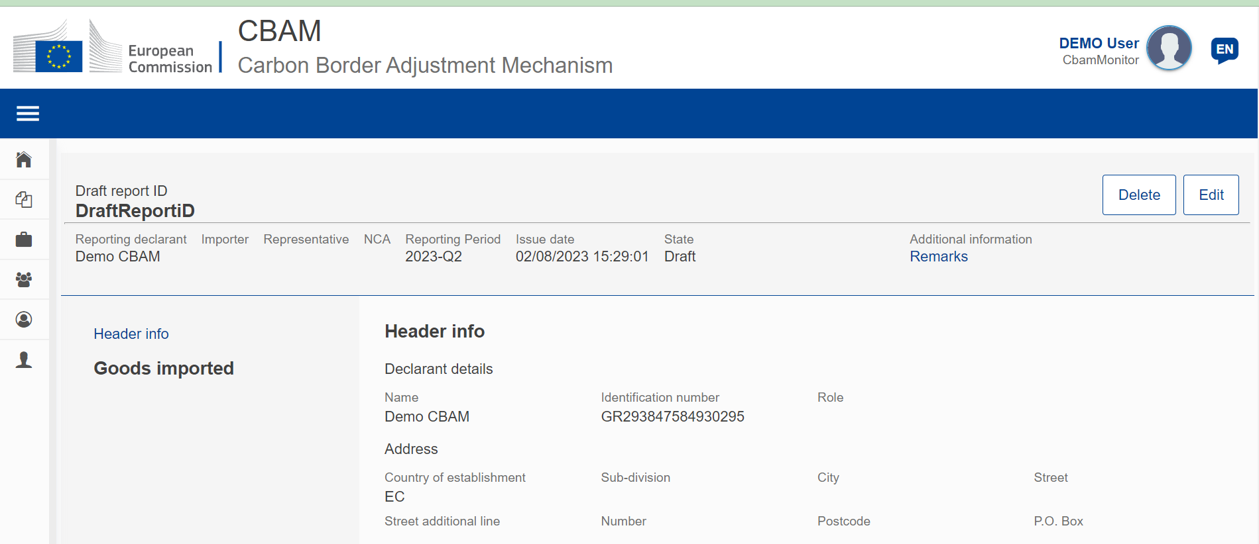
Figure 76 Delete a draft report.

A confirmation dialog will appear when the “Delete” button is clicked. The report will be deleted when the “OK” button is clicked.
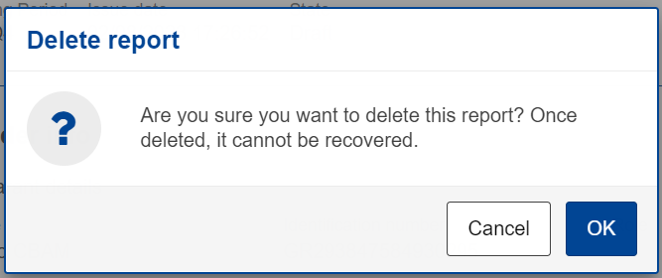
Figure 77 Delete draft report - Confirmation message

Edit a report
Editing of a report is permitted when the report is in one of the following states.
- Draft
- Under Amendment
- Under Correction
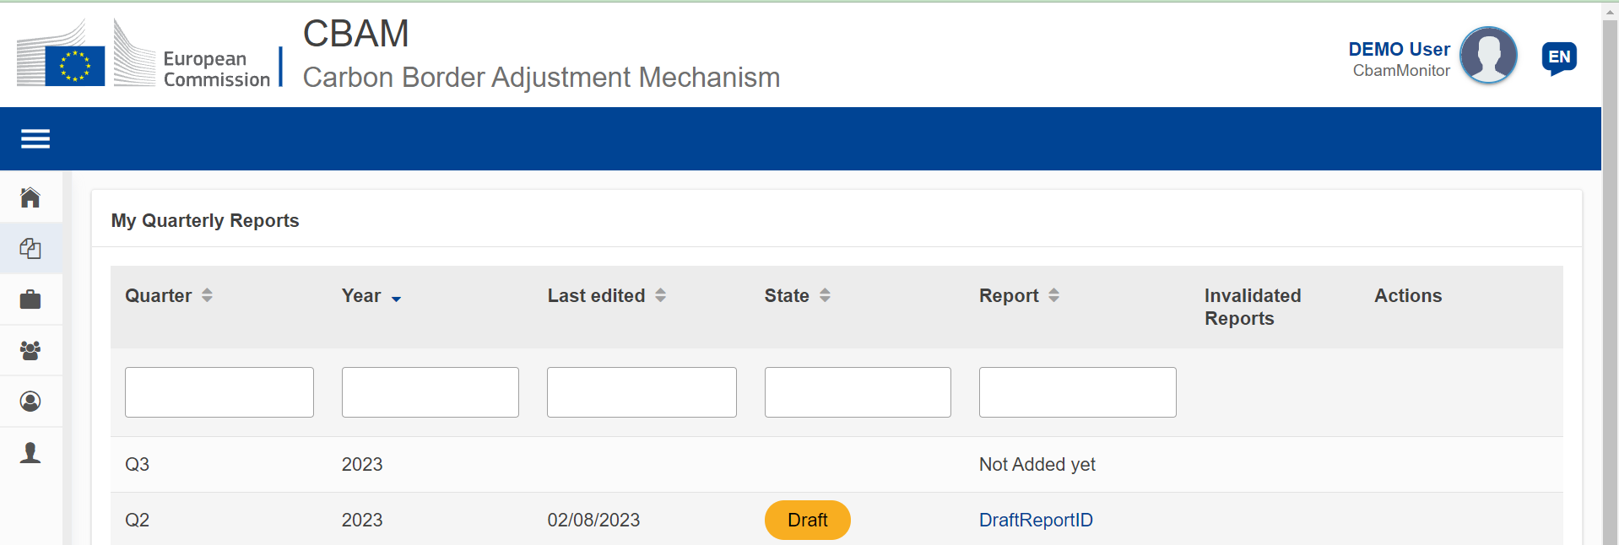
Figure 78 Edit a report.
In my quarterly reports page, click on the hyperlink in Report Column to open the report and then click the “Edit” button.
Figure 79 Edit a report

Validate a report
The report can be validated by clicking the “Validate” button located in the Actions Menu.
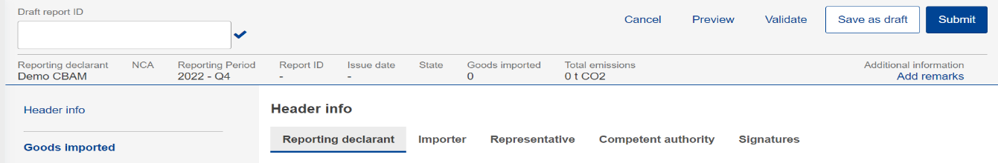
Figure 80 Validate report

Submit a report
Once the report is prepared, the CBAM Reporting Declarant needs to click the “Submit” button to officially submit the report to the CBAM Registry. CBAM System will run the validations and if no errors are found:
- The report status changes to SUBMITTED.
- The Report gets a Report ID assigned.

Figure 81 Submit report.
In case of validation errors, the CBAM Reporting Declarant will need to edit the draft report and perform corrections as needed to clear the validations error messages and click the “Submit” button again.

View a report
A report can be viewed by clicking on the “Preview” button on the Actions Menu.
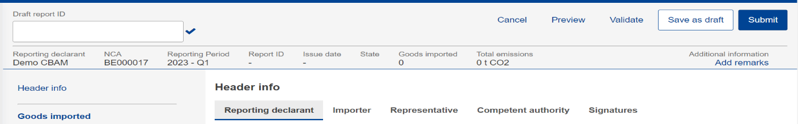
Figure 82 View report

Amend a report
When a report is in SUBMITTED state and provided the associated quarterly report submission deadline has not expired, a CBAM Reporting Declarant can perform changes to a report and resubmit it, once the validation process completes successfully.
To amend a report, locate the report with the status SUBMITTED and click the “Amend” button.
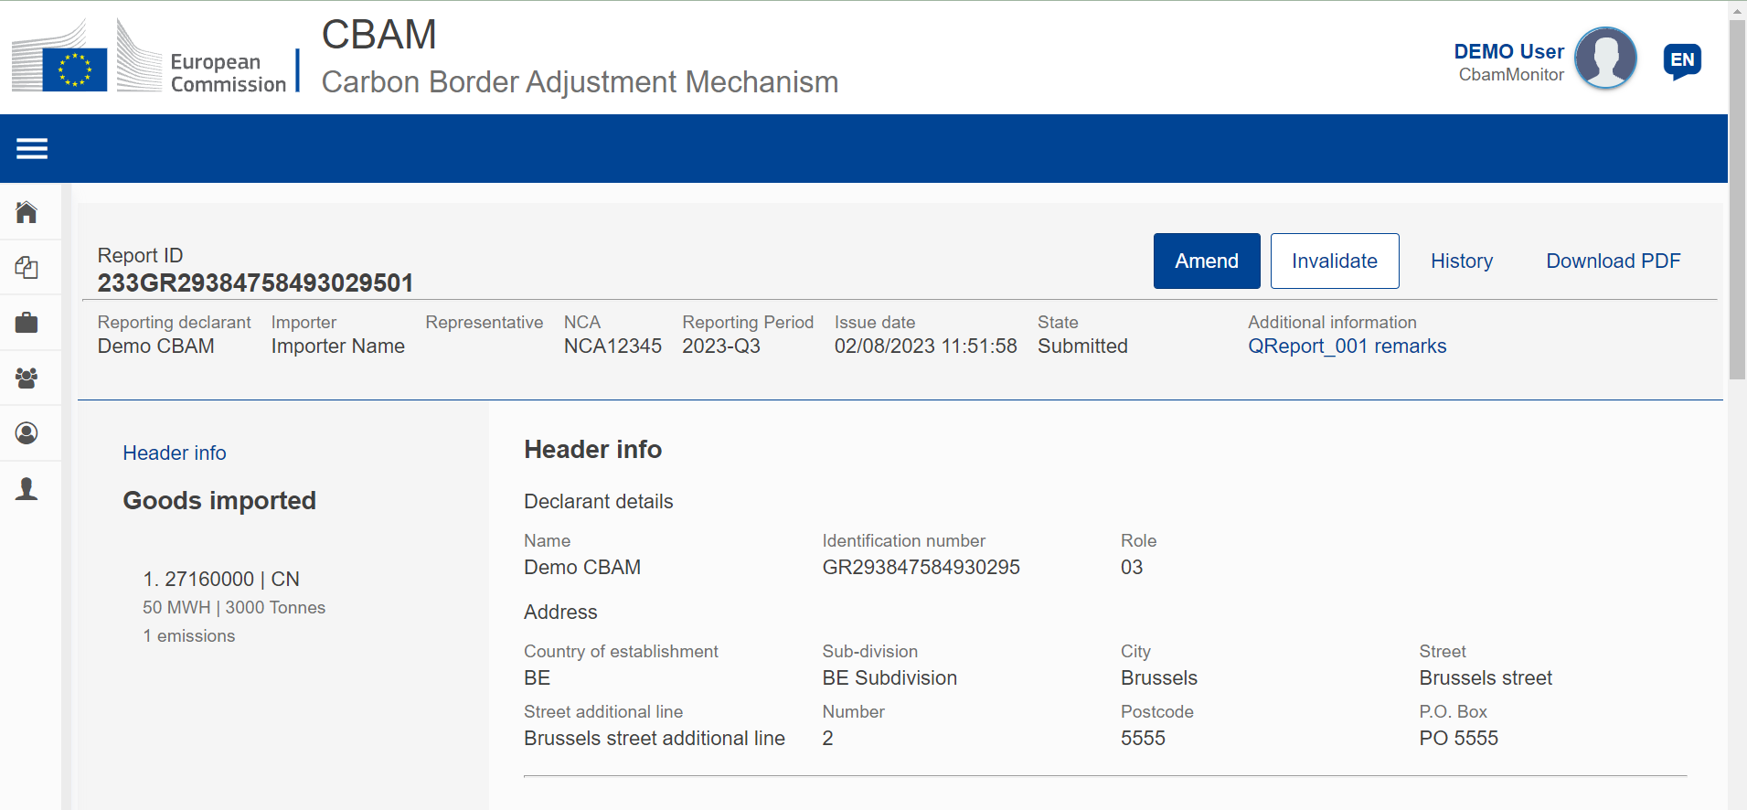
Figure 83 Amend a report.
The Report state will change to UNDER AMENDMENT. Once the changes are completed, the “Submit” button will need to be clicked.
In case of validation errors, the CBAM Reporting Declarant will need to edit the report and perform corrections as needed to clear the validations error messages and click the “Submit” button again.
The status will change to SUBMITTED again until the report state changes to REGISTERED once the associated reporting period deadline expires.
Please keep in mind that the amended report can only be submitted within the official deadline for report submission. In case the reporting period closes and the CBAM Reporting Declarant did not submit the amended report, a request for delayed report submission needs to be issued. See the 4.5.11 Request to submit a report with a process.

Invalidate a report
When a report is in SUBMITTED state, the report can be invalidated to allow a new report for the same reporting period to be created.
Figure 84 Invalidate a report.
The button “Invalidate” needs to be clicked. Upon confirming the action by clicking the “OK” button, the report state will change to INVALIDATED.
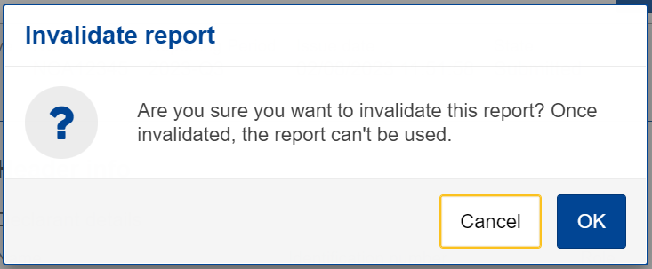
Figure 85 Invalidate report confirmation message.

Request to submit a report with a delay
The user can request to submit a report with a delay by clicking on the “Request delay” button.
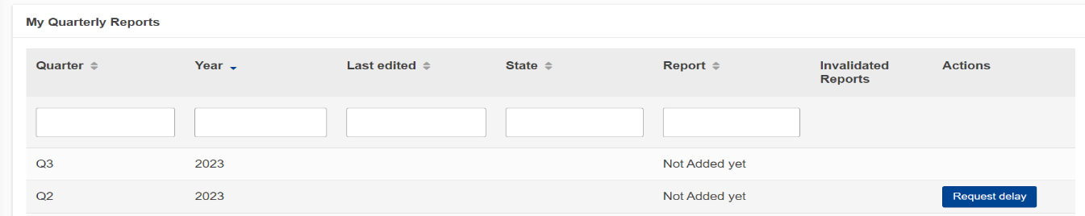
Figure 86 Request delay

Download PDF
The button “Download PDF” is available when the report is submitted. When the “Download PDF” button is clicked, a PDF is created which can be saved in your local disk drive.
Figure 87 Download PDF

History
The “History” button allows the user to see the history of the report.
Figure 88 History
Once the history button is clicked, the history view will include the actions performed, the associated report state along with a timestamp on when the action was performed.
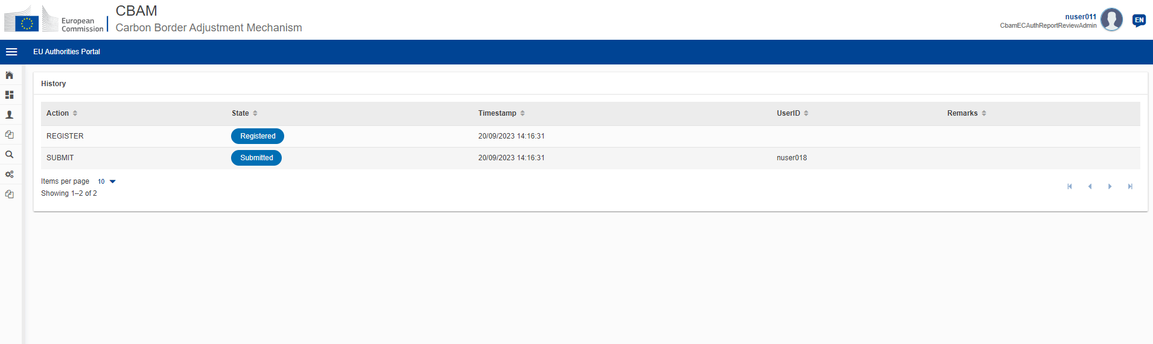
Figure 89 History

My importers
In “My Importers” menu, accessed from Home Page or through the Navigation Bar, submitted CBAM reports goods data can be compared with the corresponding goods data from the associated customs declaration.
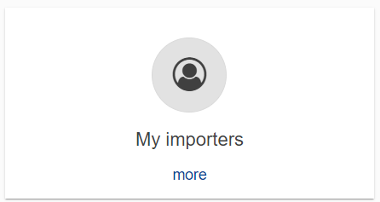
Figure 90 My Importers -Starting point.
Once the menu is selected, the list of importers included in Submitted and Registered reports (does not include draft reports) are listed.
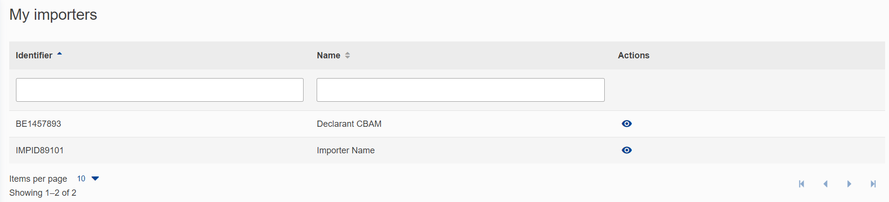
Figure 91 List of my importers
The list can be filtered either by the importer Identifier or the Importer Name. When the importer of interest is located, the “View Importer Profile” button 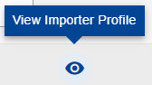can be clicked to view the Importer’s profile along with the quantity comparison of goods declared in the CBAM report vs goods in the associated Customs declarations.
Importer profile is obtained from CRS.
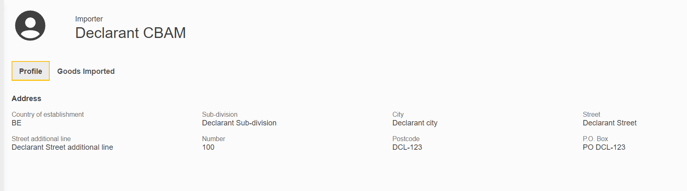
Figure 92 Importer Profile
The list of goods imported per importer, provides the comparison of CBAM Declared quantity and Customs declared quantity. In case multiple procedures are associated to review the discrepancies per procedure, you can click on the arrow to review the discrepancies per procedure.
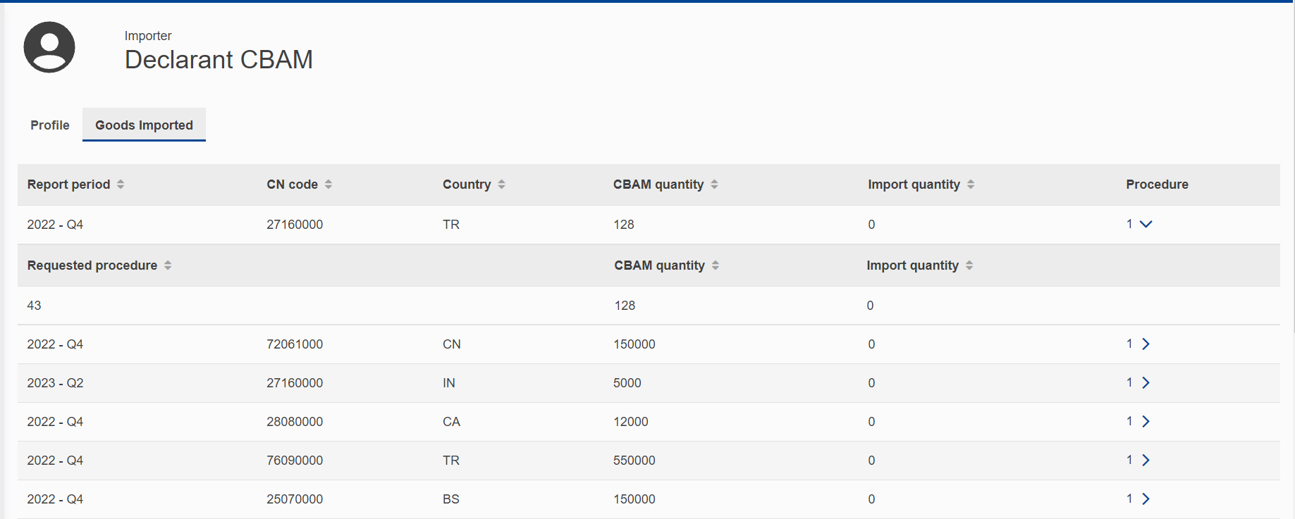
Figure 93 Importer - Goods Imported

My Profile Information
Information shown in “My profile information” is obtained from UUM&DS & CRS and are displayed as read only fields. In case the information is not accurate and needs to be corrected, please contact your NCA Authority.
A new section will be available soon to allow the CBAM Reporting Declarant to define the Contact Name, email address and phone number.
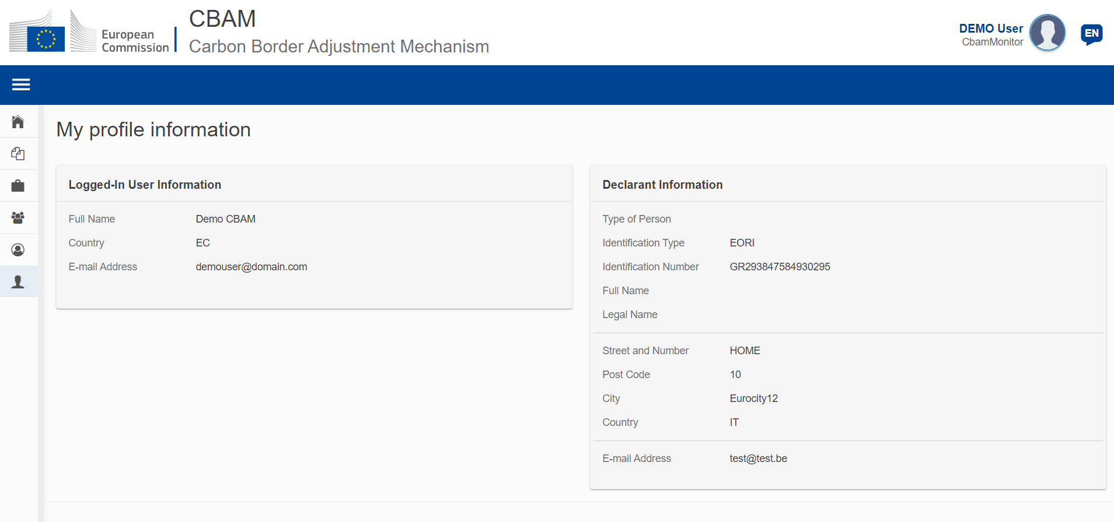
Figure 94 My profile information

Preferences
“Preferences” menu is available in upper right corner. Currently in preferences the preferred language can be defined and the default email for email communication can be defined. In future releases the “Preferences” screen will be enhanced with additional preference related attributes.
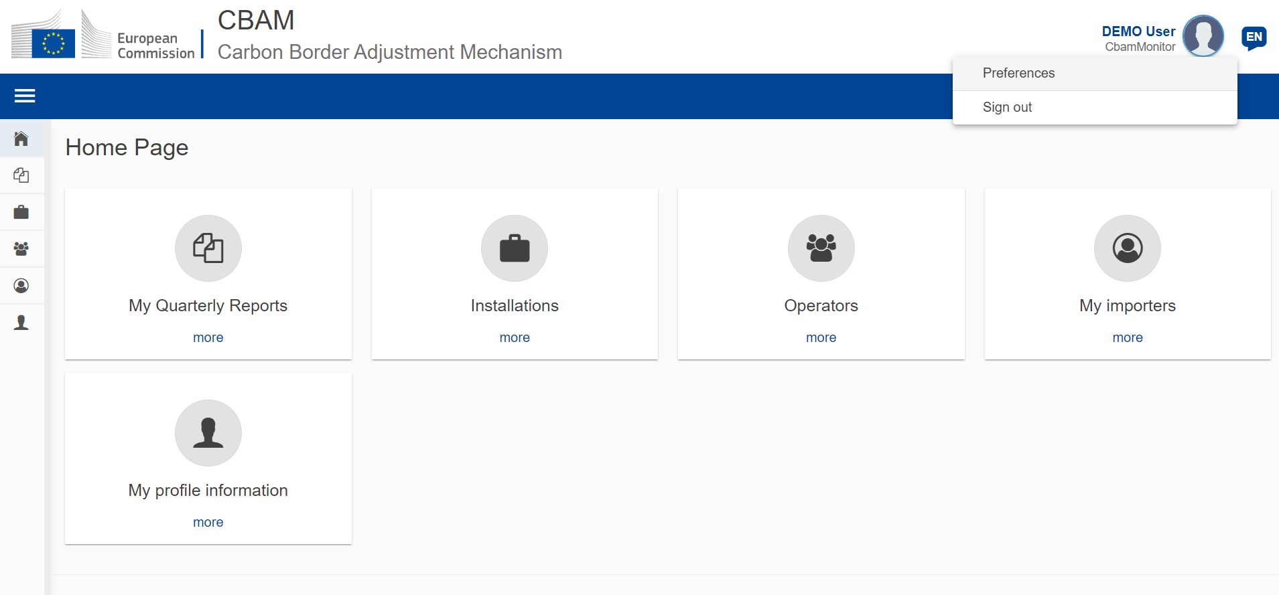
Figure 95 Preferences menu

Press the “Edit” button to fill in the required information.
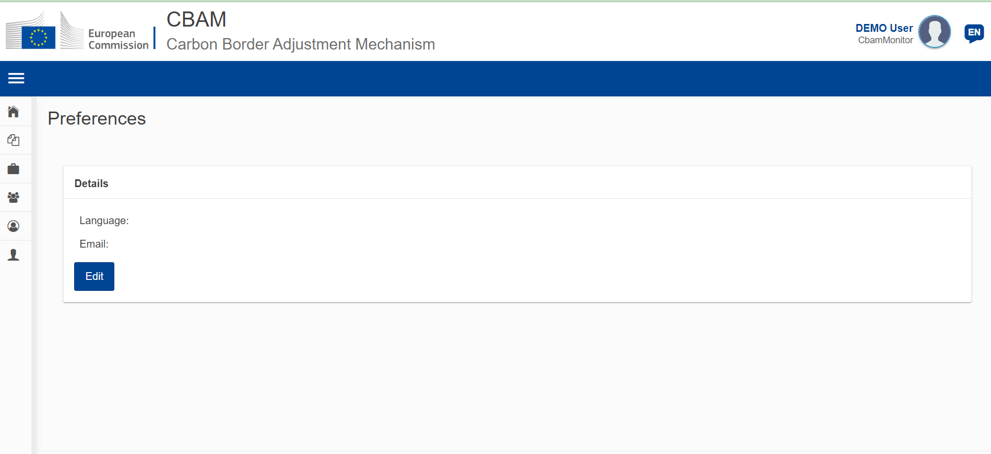
Figure 96 Preferences
To save the updated information, click the “OK” button. When the “Cancel” button is clicked, no changes will be saved.
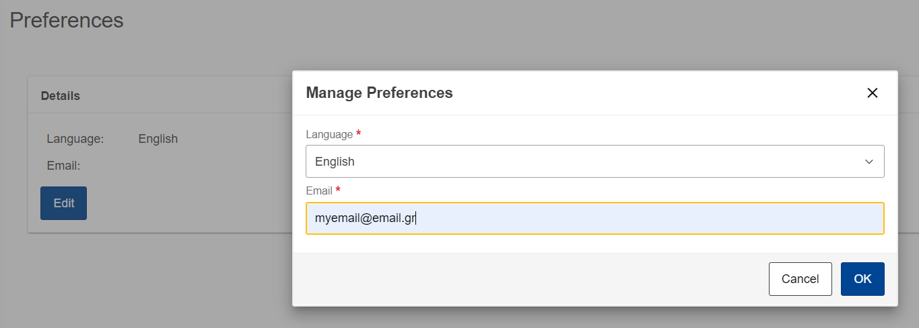
Figure 97 Edit Preferences

Appendix
N/A

Annex

CBAM Report (XSD)
The following file describes the full structure of the CBAM quarterly report in an XSD file format.

Sample ZIP file
The ZIP file must consist of:
- The quarterly report XML file created which must be based on the CBAM report XSD as provided in section:6.1 CBAM Report (XSD)
- The set of documents to be provided as binary attachments (acceptable file formats are only DOC, DOCX, XLS, XLS, PDF, JPEG, XML).
The final constructed file must be uploaded to the CBAM Declarant portal by using the “Upload” button as described in 4.5.2 Upload a report. Once the Declarant selects to create a quarterly report by uploading a file, the system fills the quarterly report’s data according to the data and binary attachments retrieved from the particular ZIP file.
The CBAM declarant can crosscheck and confirm the correct report filling to the Declarant portal UI according to the data uploaded. Potential errors are presented by the system and the CBAM declarant has to correct them in order the report to be successfully validated and submitted to the system.
Here is a sample file:

