**Area calculation for offshore wind farms**

In the licenses for Danish offshore wind farms a limited area can be used for the siting of the wind farm. The used area is calculated on the basis of a ratio of 0.22 km2/ MW, i.e. the corresponding area for the 600 MW Kriegers Flak OWF is an area of 132 km2.

The calculation is based on the coordinates for the siting of the foundations. Hence, the inter array cables, connecting the wind turbines to the offshore substation(s) are not considered in the calculation.

The total used area is calculated with Delaunay’s triangulation method, which is based on alpha values (α). α is defined as the squared radius (r2) of each triangle circumscribed circle, which reflects the distances between neighbouring points (*e.g.* wind turbines). The figure below illustrates the method with the triangle’s connecting points (*e.g.* wind turbines) as well as their respective circumscribed circles defining the α values.

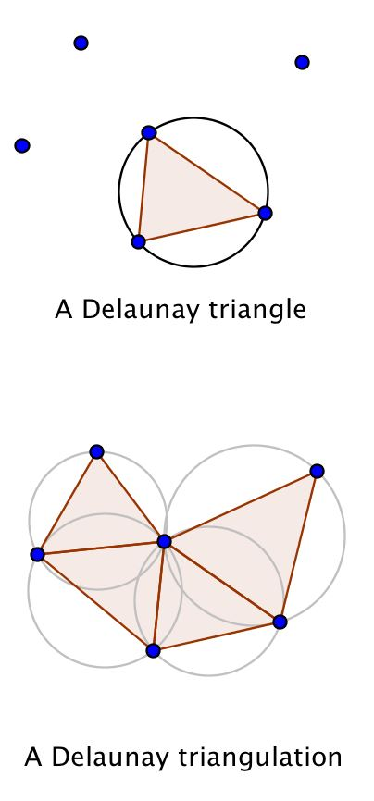 

Representation of the Delaunay triangulation method

As shown on the figure above, the alpha value increases with the distances between the points. The greater the distance between the points (*e.g.* wind turbines), the flatter the triangles become and the larger the circles, hence the larger the alpha values.

The chosen α used for the calculation of the used area for the Danish offshore wind farms has been determined on the basis of empirical analysis on existing and virtual offshore wind farms. The maximal accepted value has been fixed to α =20 (in km). Consequently, the areas resulting from $α>20$ will not be included in the overall area the wind farm covers.

This method requires that distances between the wind turbines are measured in kilometres and that each site is designed in one single area only.

In the cases where it is allowed that a wind farm is divided into several sub-sites, the total area of the farm is calculated by adding the respective sub-sites, which each has been calculated according to the method described above.

The figure below represents the application of the method for the Rødsand 2 wind farm. The cumulative exploited area is calculated to 32 km2 (31.72) for $α≤20$ and does not include the dark brown area.

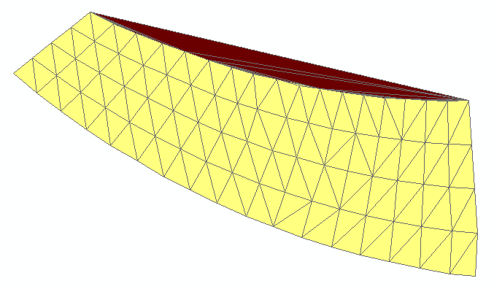

Example of the application of the method for the Rødsand 2 offshore wind farm