EUROPEAN COMMISSION
DIRECTORATE-GENERAL FOR ENERGY

Directorate C - Renewables, Research and Innovation, Energy Efficiency
C.3 - Energy efficiency

Brussels, 30 October 2015

Report to the Ecodesign Consultation Forum on the review and preparatory study concerning Lighting Products ('Lot 8 / 9 / 19')

Context
Following the recommendations of the 'Omnibus Review', which was a combined review of several regulations and one directive presented to the Ecodesign Consultation Forum on 5 May 2014, it was decided to carry out a study on 'lighting products' (Lot 8/9/19) for the preparation of further ecodesign and energy labelling requirements.
The task of this study was therefore to build upon and advance Commission Regulation (EC) No 244/2009, Commission Regulation (EC) No 245/2009, Commission Regulation (EU) No 1194/2012, and Commission Delegated Regulation (EU) No 874/2012, and explore the feasibility of unifying all three ecodesign regulatory measures into one novel regulation. To do so effectively, this study was also tasked to review Regulations 874/2012 and 1194/2012 as legally required, and follow the MEErP, extended in scope if necessary to fulfil the review requirements. The final version of the study can be found here.
Stakeholders from Member States authorities, industry, civil society and environmental NGOs were actively involved since the beginning, and two public stakeholder meetings were held. The study on lighting products was finalised in October 2015.
This report, in conjunction with the study on lighting products, fulfils the Commission's obligation to review Regulations 874/2012 and 1194/2012, and to report on this to the Consultation Forum.
To facilitate discussions with stakeholders, a preliminary draft ecodesign regulation and a preliminary draft energy labelling regulation based on the study's findings are attached. Please note that the discussion on the framework Energy Labelling Regulation is still ongoing, and some aspects such as the possible re-labelling of products already placed on the market have not been incorporated. These two preliminary draft regulations should therefore be seen as an initial starting point to facilitate discussion with Consultation Forum members and the general public.
This report starts with a brief overview on the study's key findings and first thoughts relevant to ecodesign. In the next chapter, key findings and first thoughts relevant for energy labelling are discussed. The Consultation Forum's views on these are thought.

Ecodesign
The new ecodesign regulation should follow the approach to regulate as much as necessary and as little as possible. To achieve this, the main idea behind the possible draft ecodesign regulation attached for discussion is a necessary abstraction of the scope. Defining specific lighting products through technical parameters has led to unintended consequences such as loopholes, the regulation of non-intended products and the omission of new technologies in the existing regulatory measures. To address these problems, previous fixes involved an ever increasing complexity, which reduced comprehensiveness and therefore increased the burden to comply and to verify this compliance. Rather than increasing complexity, especially in the light of still developing technologies such as light emitting diodes (LEDs) on organics LEDs (OLEDs), the Commission services belief that easy-to-understand regulations covering only the necessary aspects will improve compliance, verification and therefore the success of these measures.
The products regulated, lamps and luminaires, can basically be separated into two useful groups: lighting products and lighting product components. A lighting product is the entity of parts which can be operated, without any further modification, by connecting it to the mains electricity network, and it has the primary function of emitting light. A mains-voltage LED lamp, for example, is a lighting product.
A lighting product component is therefore a lighting product or a part thereof, which needs to fulfil at least one of three possible functions:
- to transform electrical energy into light;
- to transform electricity by supplying a different voltage, limiting the electrical current, or changing the current's directionality or frequency; and/or
- to control, process and/or regulate switching, luminous intensity and/or chromaticity of the emitted light.
Hence, a mains-voltage halogen lamp is a lighting product and a lighting product component. A low-voltage halogen lamp is only a lighting product component – a further lighting product component, a transformer, is necessary to have a lighting product.
A dimmer or sensor which is built into a luminaire with built in LEDs is part of a lighting product, because the removal would require some modification – it is within one package. On the other hand, a separate dimmer acting on a luminaire with build in LEDs, which is otherwise connected to a mains line, is out of scope if the luminaire can be operated without the dimmer.
These abstract definitions are technology neutral and independent of standards, yet cover the products to be regulated sufficiently in conjunction with a clear scope defining exclusions. This allows the draft regulation to operate without 'special purpose products', removing a constant potential of past misuse. Indeed, the study shows that no exemptions for general lighting applications will in general be necessary, because solid-state lighting technologies will be ready to replace inefficient, old technologies. This also allows for one common, technology neutral minimum energy efficiency requirement.
But this minimum energy efficiency threshold needs to be set with care; raising it too ambitiously will hinder technological development and cost user satisfaction, and raising it not at all or without the appropriate ambition will result in no policy effect. The Ecodesign Directive therefore asks its implementing acts to set ecodesign requirements according to least life-cycle costs (LLCC).
The study on lighting products shows that introducing more stringent ecodesign requirements in two stages plus an effective redesign of the label (ECO80+120+label) offers these LLCC lighting products and components emitting light:
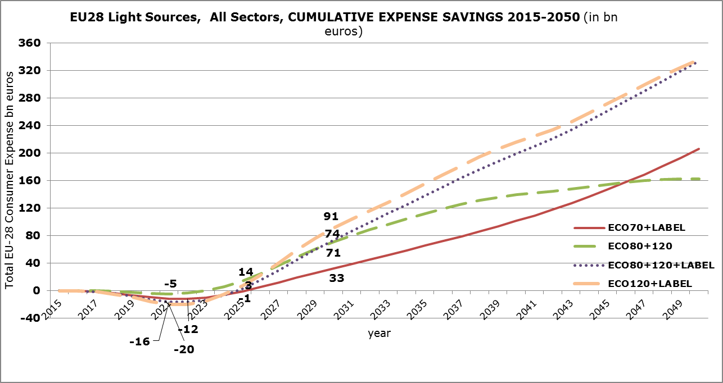
While a more ambitious introduction of minimum energy efficiency requirements at an earlier stage (ECO120+label) shows initially larger economic savings for consumers, it is questionable if such an ambitious target would be realistic given the technological development. Further, the savings are similar to the less rapid ECO80+120+label scenario on the long rung.
While only a full Impact Assessment combined with insights from Consultation Forum members can determine the correctness of these estimates, the Commission services opted for the realistic ECO80+120+label scenario in its draft regulation accompanying this report. This option is estimated to save approx. 61 TWh per year in 2030 compared to a scenario without any further regulatory measures, and will have saved the EU28 consumers around €64 billion.
The ECO80+120+label scenario implies for ecodesign moving minimum energy efficiency requirements to 80lm/W in 2020 and 120lm/W in 2024. For the regulation to become effective before 2020 and fulfil its desired aim of removing regulatory complexity and burden, an initial stage is required. The Commission services tentatively propose a 60lm/W requirement in 2018, which would be just below the energy efficiency requirement currently in force for frosted non-directional lamps, and the requirements to enter into force in 2016 for non-filament directional lamps. Further, it would have no significant negative effect on most tertiary lighting technologies, especially considering the inclusion of a CRI bonus/malus, and be in line with the latest amending Commission Regulation (EU) No 2015/1428 in that non-directional mains-voltage halogen lamps can be placed on the Union's market until 1 September 2018.

Energy Labelling
An updated of the existing energy labelling Regulation 874/2012 is deemed desirable, given the ongoing revision of the framework legislation, to ensure the continued success of the energy label for lighting products, to advance the label in light of technological progress, and to provide consistency with the ecodesign regulatory measure.
It is proposed to use the same abstraction of the scope: a revised energy labelling regulation should cover lighting products and lighting product components emitting light based on identical definitions. While an extension in scope, for example to cover battery operated equipment or non-white light sources, would be possible, the positive environmental effect might not outweigh the increased regulatory burden for manufacturers but also market surveillance authorities.
The preliminary draft regulation focuses on light emitting products only. The continuation of a separate label showing compatibility (the 'luminaire label') appears to be unnecessary, because the phase-out of old technologies and continued market uptake of solid-state technologies is expected to prevent future lock-in effects sufficiently. The new energy label would therefore be more similar to the current 'lamp label'.
The study on lighting products offers insights into the possible requirements of a future label. As an initial proposal, it proposes the following classes, which form the basis for the preliminary draft energy label regulation:

 | lm/W
EE Class | min | max
A | 210 | -
B | 185 | 210
C | 160 | 185
D | 135 | 160
E | 110 | 135
F | 85 | 110
G | 0 | 85

The application date of a new energy labelling regulation should correspond to the application date of an updated ecodesign regulation; hence both are foreseen to become applicable from 1 September 2018. Further, to enhance the effectiveness of the label, the following changes are proposed:
- to increase the minimum size restrictions of the energy label;
- to tighten requirements on the prominence of the energy efficiency class, for example by requiring this information to be mentioned at the start of any information / advertisement text; and
- to show an indicator, such as the arrow of the energy efficiency class, prominently on the package side, which is designed to face the consumer in a store.

The 'Omnibus Review' evaluated Commission Directive 96/60/EC, Commission Regulation (EC) No 107/2009, the remaining aspects of Commission Regulation (EC) No 244/2009, Commission Regulation (EC) No 245/2009, Commission Regulation (EC) No 643/2009, Commission Regulation (EC) No 1015/2010, Commission Regulation (EC) No 1016/2010, Commission Regulation (EC) No 1059/2010, Commission Regulation (EC) No 1060/2010, Commission Regulation (EC) No 1061/2010, and Commission Regulation (EU) No 547/2012.
Commission Regulation (EC) No 244/2009 of 18 March 2009 implementing Directive 2005/32/EC of the European Parliament and of the Council with regard to ecodesign requirements for non-directional household lamps
Commission Regulation (EC) No 245/2009 of 18 March 2009 implementing Directive 2005/32/EC of the European Parliament and of the Council with regard to ecodesign requirements for fluorescent lamps without integrated ballast, for high intensity discharge lamps, and for ballasts and luminaires able to operate such lamps, and repealing Directive 2000/55/EC of the European Parliament and of the Council
Commission Regulation (EU) No 1194/2012 of 12 December 2012 implementing Directive 2009/125/EC of the European Parliament and of the Council with regard to ecodesign requirements for directional lamps, light emitting diode lamps and related equipment
Commission Delegated Regulation (EU) No 874/2012 of 12 July 2012 supplementing Directive 2010/30/EU of the European Parliament and of the Council with regard to energy labelling of electrical lamps and luminaires
Methodology for the ecodesign of energy-related products (MEErP) http://www.meerp.eu/
The study is publically accessible on the project website: http://ecodesign-lightsources.eu/documents
The exact proposed definition can be found in the accompanying draft ecodesign regulation.
Commission Regulation (EU) 2015/1428 of 25 August 2015 amending Commission Regulation (EC) No 244/2009 with regard to ecodesign requirements for non-directional household lamps and Commission Regulation (EC) No 245/2009 with regard to ecodesign requirements for fluorescent lamps without integrated ballast, for high intensity discharge lamps, and for ballasts and luminaires able to operate such lamps and repealing Directive 2000/55/EC of the European Parliament and of the Council and Commission Regulation (EU) No 1194/2012 with regard to ecodesign requirements for directional lamps, light emitting diode lamps and related equipment

